**Wall Climbing Robot**

A Dissertation for

Course code and Course Title: ELO-401 & Project

Credits: 8

Submitted in partial fulfilment of Masters Degree

M.Sc in Electronics

by

Prajyot P. Sangodkar

Vijaykumar .A. Salunke

Sanjana .D. Palyekar

Roll Number:

21P036008

21P036016

21P036007

Under the Supervision of / Mentor

Dr. Aniketh A. Gaonkar

School of Physical and Applied Sciences

Electronics



Goa University

Date:

Examined by: Seal of the School**COMPLETION CERTIFICATE**

This is to certify that the dissertation / internship report **“**WALL CLIMBING ROBOT **”** is a bonafide work carried out by **Mr** Prajyot Sangodkar , **Mr** Vijaykumar .A. Salunke, **Miss**. Sanjana .D. Palyekar under my supervision/mentorship in partial fulfilment of the requirements for the award of the degree of **M.Sc** in the Discipline Electronics Discipline at the School Of Physical & Applied Sciences, Goa University.

**-----------------------**

##### Dr. Aniketh A. Gaonkar

Electronics Discipline

School of Physical & Applied Sciences

Date:

Prof. Kaustubh R.S. Priolkar School Stamp

School of Physical and Applied Sciences

Date:

Place: Goa University

**ACKNOWLEDGEMENT**

We would like to express our sincerest thanks to everyone who has contributed to this project. First and foremost, we would like to thank all the students who have voluntarily participated in this study and have provided us their time to collect their data.

##### We express our deep gratitude towards all the teaching faculty Prof. Rajendra. S. Gad, Dr. Jivan. S. Parab, Dr. Marlon Sequeira, Dr. Narayan Vetrekar and Dr. Aniketh Gaonkar for their support and guidance throughout the completion of the project. Their knowledge and suggestions have been crucial in helping us plan, carry out, and execute the project.

We would like to express our gratitude to our families and close friends for their unfailing support and inspiration during this project.

**Declaration by Student**

We hereby declare that the data presented in this Dissertation entitled, “WALL CLIMBING ROBOT ” is based on the results of investigations carried out by me in the Electronics Department at the School of Physical and Applied Sciences, Goa University under the Supervision/Mentorship of Dr. Aniketh A. Gaonkar and the same has not been submitted elsewhere for the award of a degree or diploma by me. Further, I understand that Goa University or its authorities will be not be responsible for the correctness of observations / experimental or other findings given the dissertation.

I hereby authorize the University authorities to upload this dissertation on the dissertation repository or anywhere else as the UGC regulations demand and make it available to any one as needed.

|  |  |  |
| --- | --- | --- |
| Mr. Prajyot P. Sangodkar  Seat no: 21P036008  Electronics Discipline  School Of Physical & Applied Sciences | Mr. Vijaykumar .A. Salunke  Seat no:21P036016  Electronics Discipline  School Of Physical & Applied Sciences | Miss. Sanjana .D. Palyekar  Seat no:21P036007  Electronics Discipline  School Of Physical & Applied Sciences |

Date:

Place: Goa University

**TABLE OF CONTENTS**

**INDEX**

**Sr.No Title Page.No**

CHAPTER 1 INTRODUCTION………………………………………………………………………………………………………………1

1.1 Need of wall Combing Robot……………………………………………………………………………………….. 4

1.2 Project goal…………………………………………………………………………………………………………………...4

1.3 Objectives ………………………………………………………………………………………………………………….….5

1.4 Types of Wall climbing Robot ………………………………………………………………………………………..5

1.4.1 Magnetic Wall Climbing Robots ………………………………………………………………….. 5

1.4.2 Vacuum Adhesion Wall Climbing Robot ………………………………………………………. 5

1.4.3 Hybrid Wall Climbing Robots ………………………………………………………………………..6

1.4.4 Gecko Adhesion Wall Climbing Robot ………………………………………………………….7

1.4.5 Drone Type Wall sticking and climbing Robot ………………………………………………7

1.4.6 Double – Propellers Wall Climbing Robot ……………………………………………………..8

1.4.7 Soft robotics-based wall-climbing robot ………………………………………………………9

1.4.8 Wireless Communication Wall Climbing Robot …………………………………………….9

1.4.9 Vacuum Adhesion Wall Climbing Robots …………………………………………………….10

1.5 Application of Wall Climbing Robots……………………………………………………………………………..10

1.5.1 Robots that climb walls might decrease workplace hazards………………………..10

1.5.2 Visual Inspection………………………………………………………………………………………….10

1.5.3 Crack detection……………………………………………………………………………………………11

1.5.4 Urban warfare applications………………………………………………………………………… 12

1.5.5 Security and counter ……………………………………………………………………………………12

1.5.6 Inspection and maintenance application ……………………………………………………..12

1.5.7 Nuclear power plant inspection robot …………………………………………………………12

1.5.8 Cylindrical Storage Tank Inspection …………………………………………………………… 13

1.6 Comparison of wall climbing robots to traditional cleaning method ………………13

1.7  Adhesion Mechanism………………………………………………………………………………………14

1.8 Locomotion Mechanism…………………………………………………………………………………..14

1.9 Main Components of Wall Climbing Robot……………………………………………………..15

1.10 Degrees of Freedom………………………………………………………………………………………15

CHAPTER 2 LITERATURE SURVEY……………………………………………………………………………………………………….16

CHAPTER 3 HARDWARE ……………………………………………………………………………………………………………………38

3.1 ARDUINO MEGA 2560…………………………………………………………………………………………………..38

3.1.1 What is Arduino mega 2560?………………………………………………………………………..38

3.1.2 Arduino Mega Specification …………………………………………………………………………39

3.1.3 Arduino Mega Pin Configuration …………………………………………………………………40

3.1.4 Communication ……………………………………………………………………………………………41

3.1.5 Programming ……………………………………………………………………………………………….45

3.2 MG - 966R SERVO MOTOR ……………………………………………………………………………………………46

3.2.1 MG996R Servo Motor Features ……………………………………………………………………47

3.3 5V/6V Switch Mode Ultimate BEC – Voltage Regulator ………………………………………………..48

3.3.1 Description ………………………………………………………………………………………………….48

3.3.3 Features ………………………………………………………………………………………………………49

3.3.4 Specifications ………………………………………………………………………………………………49

3.4 24V/12V to 5V 5A Power Module DC- DC XY – 3606 Power Converter…………………….49

3.4.1 Features ……………………………………………………………………………………………………..50

3.5 LM2596S DC – DC Buck Converter Supply ……………………………………………………………………50

3.5.1 Specification ………………………………………………………………………………………………..51

3.5.2 Description …………………………………………………………………………………………………..51

3.6 Orange 4500mah 4s 35c Battery ……………………………………………………………………………………52

3.6.1 Description ………………………………………………………………………………………………….52

3.6.2 Safety measures…………………………………………………………………………………………. 53

3.6.3 Specification ……………………………………………………………………………………………….53

3.6.4 Battery Capacity Calculation ………………………………………………………………………..53

3.6.5 Efficiency of Battery ………………………………………………………………………………….54

3.7 PCA 9685 Servo Driver ………………………………………………………………………………………………….55

3.7.1 Description …………………………………………………………………………………………………..55

3.7.2 Feature and Benefits ……………………………………………………………………………………57

3.7.3 Block Diagram ………………………………………………………………………………………………59

3.7.4 Pinning Information ……………………………………………………………………………………..59

3.7.4.1 PCA9685 Pin Configuration ……………………………………………………………………….50

3.7.5 Applications …………………………………………………………………………………………………61

3.8 4 channel 5V Relay Module ………………………………………………………………………………………….62

3.8.1 How does relay module function ? ……………………………………………………………….63

3.8.2 Types of Relay Based on the principle of operation ………………………….64

**3.8.3 Applications of relay module**…………………………………………………………………64

3.8.4 Disadvantages ………………………………………………………………………………………..65

3.8.5 Specification……………………………………………………………………………………………..65

3.9 Acrylic sheet …………………………………………………………………………………………………………………66

3.10 Suction motor …………………………………………………………………………………………………………….67

3.10.1 Specification ……………………………………………………………………………………………..67

3.11 Suction cup ………………………………………………………………………………………………………………..68

3.11.1 Working of suction cup ………………………………………………………………………………68

3.12 Jumper wires ……………………………………………………………………………………………………………...69

3.13 Connection of suction motor with Relay and Arduino Mega………………………………………..70

CHAPTER 4 METHODOLOGY …………………………………………………………………………………………………………….71

4.1 SYSTEM BLOCK DIAGRAM……………………………………………………………………………………………71

4.2 Experimental Setup……………………………………………………………………………………………………….72

4.3 Robotic Schema ……………………………………………………………………………………………………………73

4.4 Working ……………………………………………………………………………………………………………………….75

4.4.1 For Left side of Robot …………………………………………………………………………………..76

4.4.1.1 Initial Position…………………………………………………………………………….77

4.4.1.2 Next Position …………………………………………………………………………….77

4.4.2 For Right side of Robot ………………………………………………………………………………77

4.4.3 Initial Position to Next Position…………………………………………………………………..78

4.5 Algorithm …………………………………………………………………………………………………………………..79

4.6 Flow chart …………………………………………………………………………………………………………………..81

4.7 Challenges in Developing wall Climbing Robot …………………………………………………………..82

4.8 Result & Conclusion ……………………………………………………………………………………………………83

CHAPTER 5 Future Advancement ……………………………………………………………………………………………………85

CHAPTER 6 REFERENCE ……………………………………………………………………………………………………………………87

Appendix : code……………………………………………………………………………………………………………………………….91

**INDEX OF FIGURES**

**Figures Title Page no.**

Fig - 1 Arduino Mega 2560…………………………………………………39

Fig - 2 Arduino Mega 2560 pinouts……………………………………41

Fig - 3 MG- 966R servo motor……………………………………………46

Fig - 4 pin connection………………………………………………………..47

Fig - 5 BEC - Voltage Regulator………………………………………..… 48

Fig - 6 DC-Dc power converter……………………………………………49

Fig - 7 DC Buck Converter……………………………………………………50

Fig - 8 Battery…………………………………………………………………….52

Fig - 9 PCA 9685 servo Driver …………………………………………….55

Fig - 10 Block Diagram of PCA 9685……………………………………. 59

Fig - 11 PCA 9685 Pin outs……………………………………………………..59

Fig - 12 Relay module……………………………………………………………62

Fig - 13 Internal relay circuit………………………………………………….64

Fig - 14 Acrylic sheets………………………………………………………….…66

Fig - 15 suction motor…………………………………………………………….67

Fig - 16 suction cup………………………………………………………………..68

Fig - 17 jumper wires…………………………………………………………69

Fig - 18 Connections of suction motors………………………………70

Fig - 19 Block Diagram………………………………………………………….71

Fig - 20 Circuit Diagram…………………………………………………………72

Fig- 21.A Robotic Base Structure…………………………………………….73

Fig- 21.B Intermediate Layer……………………………………………………73

Fig- 21.C Internal Arm …………………………………………………………… 74

Fig- 21. D External Arm……………………………………………………………74

Fig- 21.E Full structure…………………………………………………………..75

Fig - 22 Code for minimum and maximum pulses…………………75

Fig - 23 code for set pluses……………………………………………………76

Fig - 24 Angle of Arms from initial to next position………………76

Fig - 25 code for set pluses……………………………………………………77

Fig -26 From initial to next position……………………………………..78

Fig - 27 Design of robot……………………………………………………….79

Fig - 28 Flow chart…………………………………………………………………81

Fig - 29 Designed wall climbing robot……………………………………84

**ABSTRACT**

The Robot, named as Wall Climbing Robot is designed to walk on the horizontal surface and to climb vertically. The robotic structure is inspired by the spider anatomy. The purpose of the robot is to climb vertical surfaces where it is difficult for humans to reach also the miniature version of this robot can be used for security purpose.

Considering these facts, this project is centric about the design and development of the wall climbing robot. The proposed design is battery operated based on Arduino mega interfaced with servo and suction motors. The combination of suction motors and suction cups are used to stick the robot to the surface. Whereas, all the movement are controlled by servo motors. The instruction for the servo and suction motors are received from controller which controls the step by step movements of the robot. The instruction are given in such a way that initially suction motors sticks to the surfaces followed by simultaneous movements of all 8 servo motors. In the next step the suction will be released for one of arm flowered by movement of servo motor of the same arm, during this process the load of the robot is being shared by the remaining 3 arms. This process will be repeated for all the 4 arms so as to move the robot in forward direction. This steps will be in the loop until the desired trajectory is completed.

**CHAPTER 1**

**INTRODUCTION:**

Robots can be used to simplify man's work. In order to do the work in an efficient manner and without tiring, robots can be used. One of such robots is the wall-climbing robot, which can be used for climbing vertical walls under load and also perform tasks such as inspection of tanks, cleaning processes, and reconnaissance. It can also be combined with land robots. The wall-climbing robots may be integrated with their mobile technology. Also, adhesion technology can be used for sticking purposes. Adhesion method selection is an important criterion for wall-climbing robots. Existing adhesion methods are mostly negative air pressure and magnetic force. Numerous studies on these techniques have been conducted. Although a common technology, in order to use air pressure, we need a pump or fan, which increases the load of the robot. Also, due to sealing problems, they are limited to smooth surfaces and nonporous surfaces. Magnetic adhesion can produce a high suction force and is relatively simple. The wall-climbing robot is one of the items with a wide range of technical applications.

Already, it has been proven through analysis that the existing adhesive methods are suitable for specific applications. Even a simple crack can lead to suction disc leakage, making the robot fail. Dust on surfaces can have negative effects on the attachments on the robot. The conventional adhesion design should not be used if the structure is unsuitable for work because it has wet, rocky, rough concrete surfaces, bricks, or rocks—likely those found on tall buildings like cable bridge towers. These structures are from remote mountain areas where winds are likely to be strong, causing the entire structure to vibrate. There is a high demand for attachment devices that can withstand strong negative forces acting against the robot. Here, we need trained human workers using steel ropes and hydraulic lifts to risk their lives for the work.

Robots will need to become capable of a wide range of modes of locomotion if they are to come into wider use in society. Here we are discussing quadruped robots, which have four legs or limbs and follow the gait pattern of quadruped animals. They are faster and more stable than bipedal robots. They may be roughly divided into two groups based on their leg configuration: mammal-type robots and sprawling-type robots. The mammal-like robot's legs are positioned vertically downward from the base. The advantages of this configuration require less torque and include faster walking capability. The sprawling type of robot contains a narrow region as it possesses a smaller footprint. Wall climbing robots (WCR) are used in situations where direct human access would be extremely hazardous or dangerous. Climbing robots can increase operation efficiency, protect human health, and save money. For example, in the military field, they can implement tasks such as aircraft inspection, surveillance, and reconnaissance, as well as target acquisition; in the chemical field, they can be used for maintenance and sandblasting of storage tanks, inspection of pipelines or gas ducts, and spray painting. The content is the same, even though the terminology differs somewhat. These infrastructures, such as buildings, bridges, nuclear power plants, oil reservoirs, marine structures, and space ships, play very important roles in our daily lives. A wall-climbing robot is known to be used in many domains, such as the nuclear industry, construction industry, fire department, petrochemical industry, shipbuilding industry, and anti-terrorism field.

Robotic climbers may be employed on both man-made surfaces like walls and natural ones like trees or cave walls. The majority of wall-climbing robots have the ability to climb either smooth or uneven surfaces. Few robots are capable of climbing both kinds of surfaces.

Not many robots can climb both types of surfaces. The majority of the robots in existence can only climb smooth surfaces. They try to copy nature’s surface climbers, such as insects, reptiles, and worms. Most commonly used by researchers to try to mimic spiders, who are the most versatile wall climbers.

Basically, the research on the wall-climbing robot has focused on two aspects: the locomotion mechanism and the adhesion mechanism. From the locomotion point of view, wall-climbing robots can be divided into four categories: legged structures, tracked structures, wheeled structures, and combined structures. These robots are often divided into four classes based on the adhesion method: magnetic, vacuum or suction cups, gripping to the surface, and propulsion type. A leg locomotion mechanism is typically implemented by a robot using a vacuum suction technique or a magnetic adhesion technique.

**1.1 Need of wall Combing Robot**

Robots that climb walls are typically used in situations where a human operator's direct access would be either prohibitively expensive due to the necessity for scaffolding or extremely unsafe due to the presence of a hostile environment.

* Painting and cleaning a building's walls takes time, poses risks to the employees, and is expensive to operate.
* Building and industry upkeep is expensive.Therefore, routine maintenance is challenging.
* Inspection of nuclear power plants is difficult for human worker.
* A robot that climbs walls could lessen the risks to people.
* Visual Inception.
* Examination of cylindrical storage tanks.

**1.2 Project goal**

The main goal of this project is to develop wall climbing robot and perform various operation like painting ,cleaning, Creaks detection and visual inspection. The purpose of using wall climbing robot is to reduce human efforts and errors. The field of robotics has application in numerous technical departments, including production, inspection, and materials handling, among others.

**1.3 Objectives**

* To create a wall climbing robot for wall painting, cleaning, and creaks detecting.
* To reduce human effort.

**1.4 Types of Wall climbing Robot**

**1.4.1 Magnetic Wall Climbing Robots -**

These robots can climb either vertically or horizontally and connect to ferrous objects like steel walls using powerful magnets. Only three of the four wheels on the wall-climbing robot with four wheels that is adsorbed on the surface of the cylindrical tank really make contact with the wall; the fourth wheel is often non-contact. This work proposes a method for solving the contact point position on the contact wheels. The constructed coordinate transformation matrix may be utilized to define the relationship between the robot and the tank's location and orientation. Calculations are made using the robot's characteristics, distribution curves, and the largest values of the wheel-wall gaps for the three contact wheels and one non-contact wheel. Through ANSOFT simulation, the impact of the wheel-wall gap on the magnetic adsorption force is discovered. It is possible to design the magnetic wheel and control of the wheeled wall-climbing robot using analysis and calculation techniques.

**1.4.2 Vacuum Adhesion Wall Climbing Robot -**

This designs a four-legged wall-climbing robot with a three-joint rotary that can maintain the level of the robot body and the supporting leg at the level of the moving process in order to meet the requirements of the four-legged wall-climbing robots in some special fields, with reference to the bionic gecko robots. The programme for solid three-dimensional design The quadruped robot's legs were created using Solid works, and a general model of the quadruped robot was produced. The leg motion simulation of the robot was carried out on a complicated terrain, and the results of the end joint and the centre of mass motion were then calculated using kinematics analysis and the 3D virtual simulation programme Matlab. The simulation ultimately establishes the viability of the leg structure design and produces the desired body level in the anticipated mobility state for the robot. For the creation of the physical prototype and the realisation of the wall movement for the next four-legged wall-climbing robot, it offers theoretical direction.

**1.4.3 Hybrid Wall Climbing Robots -**

We show a wheel-leg hybrid mobile robot that can traverse both ground and wall surfaces and perform specialized duties including rescue, inspection, surveillance, and reconnaissance. The robot's wheel-leg hybrid locomotion system allows for rapid mobility along walls, as well as obstacle bridging over walls and seamless wall-to-wall transitions. Additionally, the robot can move on both the ground and walls thanks to the wheel lifting mechanism. The robot consists of a basic body and a three-degree-of-freedom mechanical leg. A little flat sucker is located at the end of the mechanical leg, and the base body is a large flat suction cup with a three-wheeled locomotion mechanism within. The newly created chamber seal is easy to assemble and performs consistently and dependably. A distributed embedded control system that enables the robot to move manually and partially autonomously in wheeled or legged motion mode is also discussed. To examine the robot's movements on the wall, a kinematics model of the robot is constructed. Additionally, the robot's movement gait is addressed. Experiments demonstrate that the robot is capable of adhering to walls and performing simple motions.

**1.4.4 Gecko Adhesion Wall Climbing Robot -**

Geckos are quite good at moving over vertical wall surfaces. Using a strategy inspired by geckos, a climbing robot with four magnetic tracks is demonstrated in this study. This robot can be used to maintain and examine tall conical towers at wind farms. In bionics, the technical technique for configuring the robot's mechanical construction is provided, and the stability of the robot while it is perched on the tower wall in both portrait and landscape orientations is thoroughly examined. The robot is capable of adjusting to the conical curved surface thanks to the tracks and redundant joints. Additionally, the efficacy of the design strategy is speculatively evaluated, and the experiment for the robot's mobility and stability is validated in real-world scenarios.

**1.4.5 Drone Type Wall sticking and climbing Robot -**

Urban constructions require ongoing maintenance and inspection to ensure their structural soundness and users' safety, but owing to their vast height and bulk, accessing the buildings is becoming more and more difficult. Although numerous researchers have created several wall-climbing robots to address this issue, there is still no surefire answer. The risk of an unintentional fall caused by an operational malfunction brought on by the hostile environment, such as high winds and uncertain surface conditions, is one of the main reasons why existing wall-climbing robots haven't been used in the field. As a result, we sought to create an airborne robot platform that can scale walls and reach any part of a structure by flying there and sticking there while changing its stance and perching. The robot has a mobility system, similar to earlier wall-climbing robots, that allows it to travel around the structure's vertical surface. The installation of the aerial robot's wall-climbing mechanism, its pose-change and wall-sticking mechanisms, and mobility on the vertical surface of an urban structure are the topics of this article.

**1.4.6 Double – Propellers Wall Climbing Robot -**

One of the most intriguing robots is one that can climb walls since it may be used for a variety of important tasks, including military operations, wall and mirror cleaning, high-rise building inspection, and surveillance. In this study, a wall-climbing robot with propellers is created. This robot's behaviour can be understood by looking at its mathematical model. By combining the Euler-Lagrange equation, momentum conservation, blade element theory, and the aerodynamics of the propeller, the robot mathematical model is revealed. The genuine climbing robot is made using a variety of materials and fabrication techniques to produce an extremely lightweight robot. Four free wheels and two propellers make up the robot. In this study, experiments are carried out to evaluate the robot's performance. The robot can climb any surface by changing the rotor system's angle and actuating thrust, and it can also travel back to the climbing surface if it starts to fall out of a wall.

**1.4.7 Soft robotics-based wall-climbing robot -**

The objective of this research is to create a soft robotics-based lightweight wall climbing robot. This method makes advantage of the robot's pneumatic system for locomotion. The robot is a prototype for inspection applications onboard the pipe, including both interior and exterior inspections. We learned about pneumatic actuators from recent investigations, which operate when pressurized, or when a certain volume of air is pushed in. Due to the fact that they only have one bending side, these actuators may be thought of as having a single degree of freedom (DOF). In this project, we employed three different types of actuators that function as the three degrees of freedom. The robot design and preliminary experimental findings, including the stress and strain, are given.

**1.4.8 Wireless Communication Wall Climbing Robot -**

A new type of multi-processor wall-climbing robot based on wireless communication is presented. The development of mechanical structure, electronic hardware construction, software design, and multi-processor controlled system are all suggested. Positioning and path planning are specifically shown. Additionally, a communication protocol is suggested for wireless transformation of data interchange. The robot performs very well and with great precision, making it useful in a variety of industries, including shipbuilding and ship recycling.

**1.4.9 Vacuum Adhesion Wall Climbing Robots –**

A wet adhesion device with a vacuum foundation for wall climbing robots. When a suction cup is used with a tiny vacuum pump to stick to a tough surface, such as a concrete wall, this method provides adherability and low friction performance. It uses the lubricating and sealing properties of a liquid to help the robot body adhere to and slide across surfaces. The efficiency of the wet adhesion approach we suggested is confirmed by tests of friction and seal performance on smooth glass and uneven surfaces.

**1.5 Application of Wall Climbing Robots**

**1.5.1 Robots that climb walls might decrease workplace hazards**

* As it may be used for inspection and maintenance duties like construction and infrastructure inspection and surveying or even painting, a wall-climbing robot built to reduce lower workplace hazards.
* Robot for climbing tall walls while carrying a weight that may also be used to examine tanks, conduct cleaning operations, and conduct reconnaissance.

**1.5.2 Visual Inspection**

* Engineers are asked to inspect the walls and bridges for damage that needs to be fixed or rebuilt. A typical engineer examines the documentation and verifies the wall's age. To do this, visual examination is used nowadays. Even if, depending on their location, some cracks don't appear to be severe, others may result in unforeseen mishaps. Most often, cracks develop, spread, and worsen as a result of calefaction, thermal stress, severe loads, repetitive hammering, and vibration on the component. Even if the fissures are relatively small, they could not adhere to one another the same manner. Pillar cracks started to appear, moved away from the base, and stopped supporting and carrying load. The area will experience greater stress than it can sustain if there is a higher load of automobiles than the bridges can support. For further replacement and repair, it is necessary to detect further defects such dampness, traffic interruption, porosity leaks, and angle bending in walls. The choice may depend on the amount of the damage when dealing with difficult to obtain and expensive cores and parts. Other techniques, namely dry penetration tests, liquid penetration tests, pressure tests, ultrasonic tests, and vacuum tests, are used to find fractures in walls and pillars.

**1.5.3 Crack detection**

* Buildings quickly deteriorate as a result of cracking on surfaces like their walls or roofs. Getting to these locations might occasionally be exceedingly challenging for folks. The usage of climbing robots outfitted with sensing equipment is one method for dealing with such an inconvenience. We suggest an image analysis-based computer vision system for inspection. A robot dubbed Hex-piderix has a stereo camera fixed to its thorax. A methodology that is described is used to process the photos. Finding surface fractures uses an illumination-independent technique. The estimate and elimination of the illumination pattern, followed by the Otsu technique thresholding, enhance the image. Finally, fracture information is extracted using morphological procedures.

**1.5.4 Urban warfare applications -**

Monitoring and reconnaissance, delivering weapons, directing the perimeter surrounding a structure, etc.

**1.5.5 Security and counter -**

Terrorist application obtaining information on a hostile environment within a facility, etc.

**1.5.6 Inspection and maintenance application -**

Routine examination of structures, nuclear containment, and other difficult-to-reach areas, inspection of aircraft, ship hull sandblasting, etc.

**1.5.7** **Nuclear power plant inspection robot -**

A robot that can scale walls has been created with nuclear power plant inspection in mind. The compact and modular robot is entirely composed of pneumatic parts. The robot is attached to walls using vacuum suction cups so that it may climb them. The flexible pneumatic rubber cylinders that make up the mobile robot's body are used to move the robot, which can move in simple translations and rotations. Robot motion is controlled by a personal computer, and all pneumatic components' electronic valves are managed by a microprocessor. The conceptual design of the robotic system is presented in the article, along with a thorough explanation of the mobile robot's movement.

**1.5.8 Cylindrical Storage Tank Inspection -**

Robots that can scale walls have been extensively researched for use in storage tank inspection. How to choose the robot's best route from its starting point to its goal is one of the key challenges in robot tank inspection. The A-star method is a first search strategy that is frequently used in robotic route planning, although it has certain limitations. For instance, some redundant spots in the created path might be deleted, and some abrupt curves need to be smoothed down for the robot to track with. In order to optimize the produced path, a modified A-star method is suggested in this study. According to the simulation's findings, the path's abrupt curves have been eliminated and the number of way points has been reduced. Therefore, compared to the conventional way, this improved algorithm may offer a more effective path planning with smoother curves and a faster operating time without sacrificing optimization.

**1.6 Comparison of wall climbing robots to traditional cleaning method**

The capacity to cross barriers, motion control function, effective/surveillance, wireless communication relevant to the effective situation, and the ability to recognize the obstacles avoider scenario are all features of wall climbing robots. Despite its simple design, the robot will be capable of climbing porous surfaces.

Traditional cleaning procedures, on the other hand, make it difficult for a human to clean high-rise buildings or residences. Using a wall climbing robot instead of traditional cleaning methods can save time. Humans may avoid dangerous tasks like cleaning big buildings by deploying wall climbing robots, which reduces the risk. Also, if we begin deploying wall climbing robots to do the task, the amount of manpower necessary for traditional techniques will be reduced.

**1.7  Adhesion Mechanism**

Adhesion mechanism is one of the most important functions of a wall climbing robot because, with the help of this mechanism, the robot can stick to the wall properly without any failure. A vacuum pump is required to create vacuum for the wall climbing robot's adhesion system in order to develop the proper adhesion mechanism. The suction cup is attached to the vacuum pump via The rubber tube that produces the vacuum inside the suction cup and may adhere to the wall. Four vacuum pumps, each producing 30 MPa of pressure, are used to hold the robot against the wall's gravity.

**1.8 Locomotion Mechanism**

It is one of the main components of the wall-climbing robot that allows it to move on the wall without affecting the adhesion system. The choice of a locomotion system for a robot is determined by the work or task to be performed, the payload capacity, and the working environment. In this case, we need a light weight robot with good traction on the surfaces to achieve our goal of moving a wall climbing robot over vertical surfaces.

**1.9 Main Components of Wall Climbing Robot**

* Microcontroller
* Servo Motors
* Suction Motors
* Suction Cups
* Battery

**1.10 Degrees of Freedom**

Degrees of freedom are specific, predetermined motions that a mechanical system or device may make. The total number of independent displacements or motion characteristics equals the number of degrees of freedom. In two or three dimensions, a machine with more than three degrees of freedom can function. The expression is frequently used to characterize the mobility capabilities of robots. The four legs of the wall-climbing robot each have two degrees of freedom (2DOF).The legs' hip joints and knee joints each have two degrees of freedom, giving the robot a total of eight degrees of freedom (8DOF).The robot's hip joint is made to produce two degrees of freedom, one for each leg.

**CHAPTER 2**

**LITERATURE SURVEY:**

**2.1 Walking and Running of the Quadruped Wall-Climbing Robot[1]**

The study of Akihiko NAGAKUBO and Shigeo HIROSE investigates a robot's gait on a vertical and flat wall as a first step towards understanding a quadruped wall-climbing robot's general gait problem. To prevent turn over motion, the analysis employs the criteria to optimize locomotion speed within the constraints of established conditions of supporting-leg placement, order, and swing leg phases. According to the findings, the optimum standard gait, known as the "Wall Gait," holds the foot in an A-shaped position and moves the legs in the order leg1 - leg2 - leg4 - leg3 in static walking and "pace" in dynamic walking.

2.1.1 ARCHITECTURE

The quadruped robot's body form, leg numbering, and coordinate system are depicted. Each foot is believed to have three degrees of freedom (d.0.f.) of motion, as well as a suction pad linked to the ankle joint to allow for three d.0.f. rotation. When the suction pad is mounted to the wall, the foot pivots to the wall at the ankle joint.

Depending on the application, the attachment device installed on the foot may differ. If the robot is employed on a reasonably flat wall composed of common materials, it can be a hoover sucker; a magnetic device if on an iron wall; or a grasping device if on uneven surfaces.

As with the NINJA-I, the attachment device will be primarily a hoover sucker. As a result, the device is referred to as a "suction pad," and its strength of adhesion to the wall is referred to as "suction." Although the discussion is limited to this particular device, the principles can be applied to robots with other attachment devices.

1. DYANAMIC WALK OF WALL-CLIMBING

The basic dynamic gait of wall climbing has a duty factor of 0.5 and is divided into three types: pace, trot, and bound. Legs 1 and 4 on the upper side are always disconnected, while legs 2 and 3 on the lower side form the SLR axis, as a result of the bound gait. The line connecting the ankles of legs 1 and 3 and legs 2 and 4 is diagonally positioned in the trot gait, and their angle of inclination is significant. This posture has a short torso recovery action time and it is difficult to finish the swing leg recovery action. Furthermore, the kick is performed solely by the lower leg. The pace gait is the best dynamic gait for wall climbing because it has an A-shaped leg arrangement in which the legs on the lower side open from the legs on the upper side. This enables dynamic walking that always inclines into the swing leg side regardless of movement speed and does not revert to face upward. Furthermore, the recovery time of the swing legs can be freely set, which is equivalent to being able to freely adjust gravity acceleration in level ground walking and extend the time of the ballistic motion without limitation.

2. STATIC WALK OF WALL-CLIMBING

Quadruped static climbing requires at least three legs to contact the wall. The static gait under consideration is the "suction-confirmation-walk." This gait retains three or more legs in total suction, and static stability is maintained if the torso is supported by three or more legs that are not aligned in a line. The suction-confirmation-walk, on the other hand, has the limitation that the speed of motion cannot be increased since a leg cannot be released until confirmation that the action of producing suction by the preceding swing leg has been accomplished.

**2.2 Structural Design and Kinematics Analysis of a Multi-legged Wall-climbing Robot[2]**

Bin Li, Weiqi Lu, Chaowei Kang, and Shoujun Wang are the authors of this paper. Qi Li and Yong Yanga created a four-legged wall-climbing robot with a three-joint rotor that can keep the robot body and supporting leg at the same level during the movement operation. Solid works was used to design the robot's legs, and a generic model was built. The leg motion simulation was performed on a complex ground, and the end joint and centre of mass motion findings were obtained. The simulation validated the leg structure design and provided the appropriate body level in the robot's predicted mobility condition.

2.2.1 ARCHITECTURE

The leg structure, as a crucial component of the foot robot, requires not only a simple and uncomplicated construction to satisfy the set motion requirements, but also sufficient support ability to maintain structural stability. The reason for this is that an overly complicated mechanism might make structure and transmission implementation tough and difficult to run. On the other side, the overly simplistic leg construction cannot support body movement, making it difficult to assure overall stability during operation. Simultaneously, an increasing number of research scholars use the bionic joint leg as the leg structure of the multi-legged wall-climbing robot in order to realise the bionic wall-climbing robot's high bionics.

The physical prototype is an important tool for determining design feasibility and adjusting subsequent experimental conditions. This article used Solid works to create three-dimensional solid models of each component based on the relevant parameters in order to simplify computational simulation and structural observation. The four-legged robot's body is a box-type double-layer aluminium alloy plate structure, and the four leg structures are identical and use the same double-layer structure as the main structure. The intermediate position is used to insert drive components such as motors and reducers, as well as to reinforce the outer panel. The four-legged design is put in a symmetrical construction that is attractive and convenient for simplifying gait planning and control.

**2.3 Design and Analysis of an Obstacle-crossing Wall-climbing Robot Mechanism[3]**

Junke Shen and Yong Liu created kinematic equations to explore how the robot climbs over higher obstacles, grooves, cross-wall mode, and other sports as wall-climbing robots become more popular due to their ability to respond to a wide working range and pass barriers. The results show that the robot is capable of accomplishing the required tasks and has the ability to traverse borders with high speed and flexibility.

2.3.1 ARCHITECTURE

1. MOBILE MODULE

The primary body of the robot is the mobile module, which uses the negative pressure adsorption mode, an air pump, and negative pressure created by the drive servo elasticity, as well as other components. It may operate freely in differential mode to provide tiny radius steering and even in situ steering, allowing the wall climbing robot to move through confined spaces. The bottom has strong elasticity and a good sealing group, and the elastic sealing skirt can firmly cover in convex small barriers and fill a tiny groove, limiting air leakage and preserving the difference between the seal cavity and the outside atmospheric pressure. When the wall climbing robot encounters little convex impediments or grooves during its progress, it does not need to employ the crossing module.

2. CROSSING MODULE

The crossing module is made up of the following components: The steering gear is number one, with the two servos generating power. 2 is a set of reduction gears, with the deceleration device aiming to reduce the strain on the steering gear, as decreasing speed might increase torque. 3 is the connecting rod, which connects the link rod with the reduction gear. The fourth component is the support bracket, steering gear, bearings, and light connecting rod. Adsorption connects 6 and moving module and module. 5 is a lightweight link; this lightweight connection connects the mobile module to the adsorption module.

3. ABSORPTION MODULE

Adsorption module also uses negative pressure adsorption, has a high adsorption capacity, and can adapt to diverse wall surface roughnesses since it includes a sealing skirt. When the robot has to scale barriers, the adsorption module may be securely adhered on the wall, similar to the mobile module. Adsorption module provides support for the entire machine; it differs from mobile module in that it is static adsorption, hence the adsorption force is stronger than that of mobile module. The wall climbing robot is made up of three modules: mobile, crossing, and adsorption. Typically, a wall climbing robot will drive on four wheels.

2.3.2 MOTION PLANING

Obstacles on the wall surface of bridges, high-rise buildings, and other structures primarily include step surfaces, grooves, strip obstacles, cross walls, and so on. The wall climbing robot given in this study has four modes of operation: crossing convex barriers, crossing grooves, crossing acute and obtuse walls. These four modes essentially satisfy the criteria in the moving process. Crossing convex obstacles is identical to crossing groove obstacles, and crossing acute and obtuse angles are the same, therefore we only need to analyse two scenarios: crossing convex obstacles and crossing crossed walls obstacles.

**2.4 Design and Implementation of Semi-Autonomous Wall Climbing Robot Using Vacuum Suction Adhesion[4]**

Adnan Shujah, Hasan Habib, Saad Shaikh, Abdur Rehman Ishfaq, Haseeb Tahir, and Javaid Iqbal propose a semi-independent, wirelessly controlled wall-climbing robot that can scale vertical surfaces and ceilings. It is intended to increase working efficiency while also protecting human life by employing a centrifugal pump for steady suction. The mechanical components of the robot are built, and the wireless transmitter is employed to transmit video signals obtained by the camera. It is lighter and smaller than prior versions, making it suited for surveillance, inspection, and information collecting.

2.4.1 ARCHITECTURE

1. MECHANICAL DESIGN

The mechanical design is the most significant aspect of the robot; the goal of the study is to create a suction mechanism that can stick at any angle of inclination and on a variety of surface textures. Following a thorough investigation, a vacuum rotor package with reduced weight, increased power, and improved overall robot stability is designed.

2. CONTROL ALGORITHM

The robot has a control system with an electronic circuit design that incorporates several aspects. Figure 2 depicts the control algorithm block diagram, with the wireless transceiver module handling the motors, pan and tilt mechanism. The wireless receiver controls the motor controller, suction rotor package, drive motors, H-Bridges, and wireless camera receiver directly. To regulate the speed of the motor, the motor suction controller requires duty cycle variation. The speed of the motor is related to the low pressure induced in the suction chamber. As the motor speed increases, the amount of air escaping through the impeller increases, resulting in a low-pressure zone. As a result, a pressure sensor within the suction chamber is required to monitor the pressure inside, which varies based on the surface roughness and imperfections, allowing air to enter the suction chamber.

2.4.2 ACTUATORS

1. OUTRUNNER MOTORS

The shaft of the outrunner motors revolves with the exterior body. Another advantage of these motors is that they are cooled by the air flow generated by the outer body. However, these motors do not have very high RPMs, such as 4000, which we require. The maximum rpm we could get was 1750, which did not totally meet the design criteria.

2. INRUNNER MOTORS

The internal shaft of the motor is the only part of the motor that rotates. These quickly become hot, and there is no built-in cooling mechanism. For the passage of air, holes are made in the motor. Various experiments and tests on the motor are carried out. When running at 3 amps without a load, the motor gets hot.

**2.5 Design, Fabrication and Testing of a Miniature Wall Climbing Robot Using Smart Robotic Feet[5]**

The wall-climbing robot with two smart robotic feet (SRF) was created and tested by Gregory Wile* and Dean M. Aslam. It has a vacuum pump, pressure sensor, micro valve, and suction cup, as well as a PIC16F876 microcontroller and an internal 6 volt power supply. The robot's mobility is powered by two electrically coordinated and linked servo motors. Its purpose is to travel between a floor and a wall, to change direction while walking on a surface, and to climb vertical walls.

2.5.1 ARCHITECTURE

1. SMART ROBOTIC FEET

The SRF discussed in this study was developed expressly for use with this robot. It has a modest dimension that allows it to be installed as a single item and can be readily removed or maintained. The components comprise a self-machined polycarbonate mounting block that serves as a central connection for the other components. An airtight seal is created by securing a suction cup with a 40 mm diameter base in a clamp assembly connected to the underside of the mounting block. A diaphragm-type micro-pump measuring just 27.1 mm 16.9 mm 28 mm is mounted to the mounting block's top and creates suction in the cup. The pressure inside the suction cup is monitored by a pressure sensor positioned on the side of the SRF. It was feasible to create a pressure of roughly 77 torr within the suction cup using a current of 45 mA. The SRF additionally has a 3V micro-valve that is solenoid activated. When the SRF is ready to be lifted, the valve allows air to enter the suction cup. The valve allows for quicker suction cycles, which leads to faster walking pace.

2. ROBOTIC BODY

The robotic frame is built mostly of machined polycarbonate plastic. Polycarbonate is a lightweight material with high strength, thermal and electrical qualities. The frame's components are attached with varying lengths of stainless steel machine screws, and their kinematics allow the robot to walk in a variety of ways. The robot's motions are powered by two Hitec HS-311 servo motors, which were chosen for their small weight, high torque, and accurate angular positioning capability. One servo (Servo 1) controls the legs' motion in the vertical plane, while the other (Servo 2) controls their motion in the horizontal plane. This was considered to be the most convenient configuration since it allowed for independent control of the height and length of each step. Views of the robot's frame with the servos mounted are shown in Figures 2a and 2b. The robot is 108 mm high, 106 mm broad, and 101 mm long when standing erect.

**2.6 Development of a Wall Climbing Robot with Wheel-Leg Hybrid Locomotion Mechanism[6]**

Yili Fu, Zhihai Li, Hejin Yang, and Shuguo Wang created a ground-breaking self-contained wall-climbing robot prototype for specialized tasks such as rescue, inspection, surveillance, and reconnaissance. The robot is made up of a basic body and a mechanical leg with three degrees of freedom and a flat sucker at the end. The robot may move manually and somewhat autonomously in wheeled or legged motion mode thanks to a networked embedded control system. A kinematics model is built and the robot's movement gait is addressed to investigate the robot's motions on the wall. The safety of the robot on vertical surfaces is proved.

2.6.1 ARCHITECTURE

The design of the locomotion mechanism is linked to the design of the adhesion mechanism. The robot uses vacuum adhesion to adhere to vertical surfaces. The locomotion mechanism moves as a result of the robot's dependable adherence to surfaces. The wheel-leg hybrid locomotion system is made up of two parts: a wheeled mechanism and a climbing mechanism. The biped wall-climbing robot inspired the climbing mechanism. For biped robots, two suckers are always installed in each foot. Biped robots must always have at least four degrees of freedom in order to move forward, backward, and turn. In this case, the wheeled locomotion mechanism may alter the orientation of the robot, requiring just three degrees of freedom for the climbing mechanism. The wheeled locomotion mechanism is assigned to drive the robot to achieve omni-orientation mobility. The climbing mechanism, on the other hand, is assigned to step over barriers.

Mass - 9.5 Kg

Size of base body - 300×300×85 mm

Size of small sucker - 150×450×3 mm

Speed of wheeled mechanism - 10 m/min

Speed of legged mechanism (time to step over a ledge) < 12 s

Load capacity of big sucker - 40 Kg

Load capacity of small sucker - 30 Kg

2.6.2 ROBOT’S MOVEMENT

The hybrid locomotion system allows the robot to move in two modes: wheeled and legged, which enhances its mobility. The wheeled motion mode is intended for fast mobility, while the legged motion mode is used to overcome obstacles. The robot's obstacle-spanning motions may be classified into two types: span protrusion and span gap. The movement sequence for across a ledge is broken into four phases:

1) The robot approaches the cliff

2) the mechanical leg is extended to drive it over the ledge, allowing the flat sucker in the foot to attach to the surface

3) the base body is lifted over the ledge

4) the base body falls on the surface, releasing and retracting the climbing leg.

The transition from floor to wall is accomplished through a series of four movements: approaching the wall surface, extending the mechanical leg to place the foot on the wall surface, lifting the base body onto the wall surface, landing the base body on the vertical surface, and releasing the climbing leg.

**2.7 Dry Adhesion Optimization Design for a Wall-Climbing Robot Based on Experiment[7]**

The Taguchi approach was utilised by Yanheng Liu, Myeongseok Shin, Kyungmin Jeong, and TaeWon Seo to discover the optimal foot pad design for vertical climbing on an acrylic surface with various curvatures. To achieve a robust optimal design, design parameters such as shape, area, thickness, and foam thickness were utilized. In the trials, variously curved acrylic surfaces were employed. Based on the results of the tests and analysis, a better foot-pad was chosen, and the wall-climbing robot's stability was proven.

**2.8 Development of a Wall Climbing Robot for Ship Rust Removal[8]**

ZhengyaoYi, YongjuGong, and Zuwen Wang Xingru Wang created a wall-climbing robot for ship rust removal (WCRSRR). It is the executive body in the ultra-high pressure water jetting full equipment set (UHPWJCE) for rust removal. Three technological issues have been resolved: the adsorption method, the driving methodology, and the control approach. The ascending driving torque equation takes into consideration the kind of permanent magnetic, gravity centre position shift, and weight of the pipeline load. The ascending driving torque equation is used in simulation to assess the driving characteristic. The prototype and testing show that the robot adsorption mechanism is reliable, as are the driving and control systems.

2.8.1 ARCHITECTURE

1. Design Index

The design index of UHPWJCE is listed as follows:

(I) Working medium: pure water,

(2) Pressure of heavy power pump: 250MPa,

(3) Jet flow rate: 27L/min,

(4) Motor power: 132kW,

(5) Volume of vacuum Tank : 1500L,

(6) Degree of vacuum:-0.6bar,

(7) Quantity of air drawing : 30m3/min,

(8) Robot maxspeed:50mmls,

(9) Rust removal quality grade: Sa2.5,

(10) Robot rustwidth:250mm,

(II)Robot body weight : less than90Kg,

(12) Robot loading ability: 80Kg

2. ROBOT STRUCTURE

The WCRSRR body is made up of four components: an adsorption mechanism, a walking mechanism, a driving mechanism, and a frame. It has an overall size of 735x752x280 mm3 and is centrosymmetric. The adsorption mechanism consists of two crawlers equipped with 72 permanent magnets, while the walking mechanism consists of crawlers and sprocket shafts. The driving mechanism consists of two servo motors and two reducers, which are placed at opposing angles.

**2.9 Wall Climbing Robot using Soft Robotics[9]**

Lad Pranav Pratap, Pawar Mansi Shailendrasingh, Aman Anand, and Tharun V. P. want to build a lightweight wall climbing robot using soft robotics and a pneumatic mechanism for mobility. It is a working prototype for inspection applications aboard the pipe, such as interior and exterior inspections. Pneumatic actuators have a single degree of freedom (DOF), and stress and strain calculation is included into the robot design and early testing results.

2.9.1 ACTUATORS

Soft actuators, which alter volume as air is pushed into them, are used in robot movement systems. The route that these materials take while inflating is determined by the qualities of the material utilised, such as the geometry of the wall thickness, gaps, and sections formed. Stretchy and stiff materials are employed to regulate the bending of the actuator. When the air is compressed, the stretchy material expands more than the rigid material, causing the actuator to twist and bend.

1. ACTUATOR DESIGN

The actuator is composed of two parts: stiff and elastic. The elastic part is made of smooth-on Company's Ecoflex 30, while the stiff component is made of layers of paper at the bottom. When air is pumped into the chamber, the part where the rigid paper is inserted remains unchanged, resulting in the actuator's bend.

1. MOLD DESIGN

The substance used to make actuators is liquid, and a mould into which the liquid may be poured must be created. This mould is made through 3D printing, which should be done at a high resolution to guarantee the liquid has a printed surface finish.

SPECIFICATION OF ROBOT

* + Length of cylinder : 20 cm
  + Diameter of cylinder : 25 mm
  + Inner diameter of cylinder : 20 mm
  + Pressure inside the tube : 40 psi
  + Tube material Ecoflex : 30
  + Fibre inextensible : Kevlar Fibre
  + 3D printing material : PolyLactic Acid

**2. 10 A Wall Climbing Robot for Oil Tank Inspection[10]**

To prevent spills and calamities, oil refineries must examine hundreds of storage tanks. Love P. Kalra* and Jason Gu*t developed a wall-climbing robot employing a permanent magnet adhesion mechanism and a non-destructive sensor. It may be operated manually or mechanically, and it can be commanded remotely from the ground station. To examine the prototype, a test experiment was carried out.

2.10.1 ARCHITECTURE

1. MECHANICAL STRUCTURE

The outer walls of oil storage tanks, which are constructed by welding rectangular portions of steel plates, serve as the robot workstation. This production procedure results in 2-3 cm welding seams at the joints, as well as a welded stairway on the wall surface to access the roof. To overcome these constraints, a crawling type locomotion was used, which permits steady locomotion along the vertical walls of the tanks and over the welding seams without losing grasp on the wall. The welding joints must be evaluated for weakness caused by stress and corrosion, and the steel sections must be inspected for any internal flaws, which may be done with non-destructive sensors such as ultrasonic or eddy current sensors.

1. DRIVE MECHANISM

The proposed WCR is made up of a box-shaped aluminium frame, motors, a drive train, and tracked wheels with permanent magnets installed in steel channels that are regularly spaced. This robot includes a differential drive system, which allows for tremendous manoeuvrability and the ability to spin the robot on its own axis. The robot is driven on vertical surfaces by two 24V DC motors with a 15:1 planetary gearbox. To attain the specified speed of lOm/sec, the motor speed was further decreased by utilising worm gears with a gear reduction ratio of 20:1, which operate as a brake when the robot stops vertically, preventing the robot from sliding down under gravity. This system conserves energy by breaking the motor.

1. WHEEL DESIGN AND MAGNETIC STRENGHT EVALUATION

The tracked wheel is made up of a driving sprocket, a driven sprocket, a rubber belt, and steel magnet cups that are connected to the belt with bolts. Each track has 26 magnets, with 10 of them always in contact with the wall surface. The drive train system enables for additional surface area to be used to install permanent magnets near the contact surface to produce adequate attraction force to keep the robot on the wall while also allowing for flexibility to cross over tiny impediments. The belts are 5 cm broad, 8mm thick, and 1.15 metres in diameter. The entire machine was constructed using identical sprockets with 47 teeth.

1. ADHESION MECHANISM

A driving sprocket, a driven sprocket, a rubber belt, and steel magnet cups bolted to the belt comprise the tracked wheel. Each track has 26 magnets, 10 of which are constantly in contact with the wall surface. The drive train design enables the utilization of more surface area to put permanent magnets near the contact surface in order to provide enough attraction force. The belts are 5 cm wide, 8mm thick, and 1.15 meters long. Unlike other options such as vacuum suction cups, which require a constant source of negative pressure to stick, the complete machine was built using identical sprockets with 47 teeth.

**2.11 Design and Development of a Robot for Wall Climbing[11]**

Scientists have been attempting to drive vehicles in both the vertical and horizontal planes at the same time for a very long time. Rolling the wheels on a surface that is very steeply inclined to the ground plane was challenging due to working against gravity. The design and development of a wirelessly controlled motor vehicle that can operate in both a vertical and horizontal plane are the topics of this research article. The vehicle has been held in any inclined vertical plane using aerodynamic procedures. The paperwork includes both mechanical and electrical components. Solid works and 3D Studio Max were used to create the mechanical portion, while Proteus VSM was used to develop and simulate the electrical components.

2.11.1 ARCHITECTURE

1. MECHANICAL PART

The mechanical element of the robot is built using aerodynamic technology. In the centre of the body, a vacuum chamber is formed, into which an electrical suction cup is fitted to secure the robot to any sloped surface. The BLDC motor's speed is controlled by an RF transmitter receiver. Inside the suction cup, a ductted impeller with a high-speed BLDC motor flows air to the outside direction of the vacuum chamber, exerting force on the robot to stick it to the wall. To regulate the speed of the motor, a 2800KV BLDC motor with 45A ESC driven by a 4 cell Lithium Polymer battery is employed.HP four micrometal gearmotor

1. ELECTRICAL PART

The electrical part of the robot is based on microcontroller and wire-less technology. An Android application named ArduionoRC was used to send command from the Android device to the Bluetooth module. The ZS-040 Bluetooth module was used to receive the command from the Android device. Arduino UNO R3 with ADAFRUIT motor shield was used to drive the micrometal gear motor according to the command. TB6612 MOSFET driver was used instead of L293D with 1.2A per channel and 3A peak current capability.

Arduiono RC allows the user to set a UUID of their own Bluetooth module in order to connect the Android application with the project. This software contains 4 different command modes which enabled precise control of the robot in vertical plane.

**2.12 Mechanical design and installation of wall-climbing robot[12]**

Robots that can climb vertical surfaces are called wall climbing robots. The design and construction of a quadruped climbing robot are discussed in this study. We must develop and build a robot that can climb walls by using suction to adhere to the wall. Two servo motors will move the robot's legs while Basic Stamp will be used to operate it. Legs on the left and right sides of the robot will be moved by servo motors. Through the use of a slider and crank, the leg rotations imitate walking motions. Two intermittently operating vacuum pumps will provide the suction force. The robot will be mobile since all of its parts—aside from the compressor—will be carried by its primary body. Right now, the robot can only travel in a straight path. Plans to include manoeuvrability and other features can, however, be put into action when the initial stage of development succeeds.

2.12.1 ARCHITECTURE

1. MECHANICAL DESIGN

The goal of this design is to keep all sucking cups vertical to the wall surface. Two servo motors are utilised to control the movement of the legs, and a slider-crank mechanism is employed to keep the leg perpendicular to the wall's surface. The basic stamp controller, servo motors, pneumatic valves, and pneumatic pumps may all be carried by the robot's main body. At some point, just two legs will make contact with the surface of the wall, necessitating the use of a base support to keep the robot stable.

2. ROBOT MECHANISM

The robot's mechanism comprises of two servo motors and four legs, with the two motors' functions being to create rotational motion in just two legs (legs 1 and 4). The remaining two legs support the robot's body during movement. The slider-crank mechanism is made up of the links. The slider section and sucking cup are attached to each of the four cranks. Only the slider-crank mechanism of suction cup 1 and 4 legs will cause the robot to move, but the remaining suction cup legs will not. cup 2 & 3 will remain locked in place. During circular motion, all of these positions (1,2,3, & 4) will occur.

3. SUCTION MECHANISM

The following considerations were taken into account when developing the robot's suction system:

1. During the rotating action of the legs, ensure that all sucking cups are vertical to the wall surface.

2. Using vacuum pumps with high pressure levels to stick suction cups to the surface of standard wall construction.

4. ELECTRONIC DESIGN

The robot's electronic design consists of combining circuits of various functions with the Basic Stamp BS2 module. BASIC Stamp modules are microcontrollers (small computers) that may be used in a variety of applications. A BASIC Interpreter chip, internal memory (RAM and EEPROM), a 5-volt regulator, a handful of general-purpose I/O pins, and a set of built-in instructions are all included in each BASIC Stamp.

PBASIC, a simplified yet tailored version of the BASIC programming language, is used to create BASIC Stamp modules, which can handle a few thousand instructions per second. The Basic Stamp BS2 modules can be linked via serial ports or USB, and programmes are sent and stored in the basic stamp via these ports.

**CHAPTER 3**

**HARDWARE**

**3.1 ARDUINO MEGA 2560**

The At mega 2560 microprocessor is the foundation of the Arduino microcontroller board. The expanding environment of this board executes the processing or wiring language. Due to their user-friendly platforms, which enable anybody with little to no technical experience to get started learning programming and manage the Arduino board, these boards have revitalized the automation industry.These boards are used to expand standalone interactive goods or link to PC applications like Max MSP, Processing, and Flash.

**3.1.1 What is Arduino mega 2560?**

Micro controller boards like the "Arduino Mega" use the ATmega2560 micro controller. Uts It features 54 digital input/output pins, of which 14 are used as PWM outputs and 16 are analogue inp. It also includes 4 hardware serial ports (UARTs), an ICSP header, a power connector, a USB port, and a RST button. The majority of the components needed to support the microcontroller are on this board. A USB connection, a battery, or an AC-DC converter can be used to power this board from a computer. To protect this board against an unexpected electrical discharge, use a base plate.

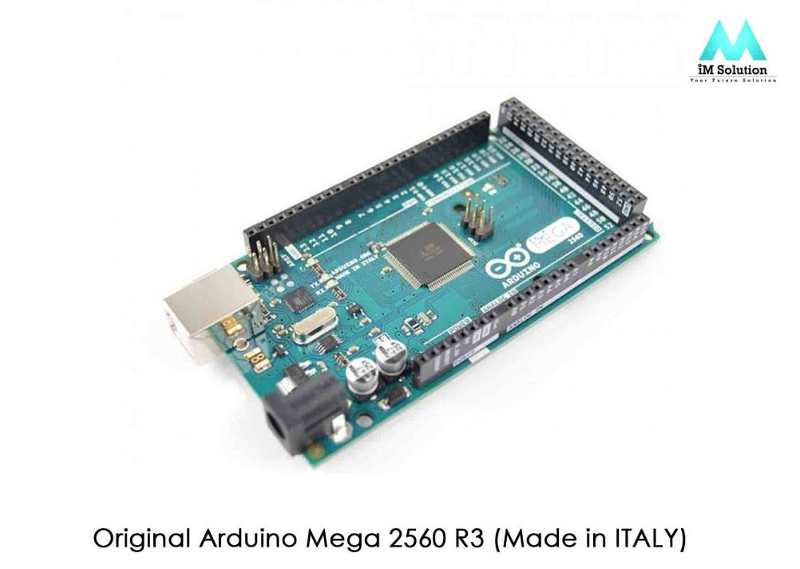

Fig - 1: Arduino Mega 2560

The AREF pin is linked to the SDA and SCL pins of the Mega 2560 R3 board. The RST pin is also close to the two most recent pins. The Arduino board's voltage may be changed by the shields thanks to a pin called IOREF. These boards can be modified to function with later shields that use these additional pins, however they currently operate with any old shield.

**3.1.2 Arduino Mega Specification**

Specifications of Arduino Mega include the following:

• The ATmega2560 is a Microcontroller.

• The operating voltage of this Microcontroller is 5volts.

• The recommended Input Voltage will range from 7volts to 12volts.

• The input voltage will range from 6volts to 20volts.

• The digital I/o pins are 54 where 15 of these pins will supply PWM output.

• Analog Input Pins are 16.

• DC Current for each input/output pin is 40 mA.

• DC Current used for 3.3V Pin is 50 mA.

• Flash Memory like 256 KB where 8 KB of flash memory is used with the

help of boot-loader.

• The static random access memory (SRAM) is 8 KB.

• The electrically erasable programmable read-only memory (EEPROM) is 4 KB.

• The clock (CLK) speed is 16 MHZ.

• The USB host chip used in this is MAX3421E.

• The length of this board is 101.52 mm.

• The width of this board is 53.3 mm.

• The weight of this board is 36 g.

**3.1.3 Arduino Mega Pin Configuration**

Below is a diagram illustrating the pin layout of this Arduino mega 2560 board. There is a specific function associated with each pin on this board. This board's analogue pins may be utilized as digital I/O pins in their entirety. The Arduino mega project may be constructed with this board. These boards provide flexible workspace, additional memory, and computing capacity, enabling instantaneous operation with many types of sensors. These boards are physically superior to other kinds of Arduino boards.

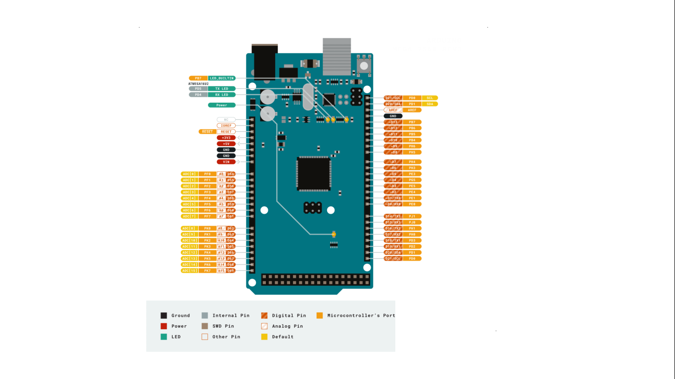

Fig 2: Arduino Mega 2560 pinouts

1. Pin 3.3 V and 5v

O/P controlled voltage of about 5V is provided by these pins. Powered by an RPS (regulated power supply), the Arduino mega board's microprocessor and other components may operate. It can be obtained through the board's Vin-pin or another regulated voltage source, such as a USB cable or 5V power supply, although the 3.3V0-pin can provide another kind of voltage control. 50mA is the maximum power this device can draw.

1. GND Pin

The 5-GND pins on the Arduino mega board are available for usage anytime the programme calls for it.

1. Reset (RST) Pin

This board's RST pin may be used to rearrange the board. This pin can be turned low to reorganize the board**.**

1. Vin Pin

The board may receive input voltage in the range of 7 to 20 volts. Through this pin, the voltage supplied by the power jack may be accessed. However, a 5V output voltage will be set up automatically through this pin to the board.

1. Serial Communication

To send and receive serial data, this board's serial pins TXD and RXD are used. Information is transmitted when a Tx is used, and data is received when an RX is used. There are four configurations for the serial pins on this board. Tx(1) and Rx(0) are included for serial 0, Tx(18) and Rx(19) are included for serial 1, Tx(16) and Rx(17) are included for serial 2, and Tx(14) and Rx(15) are included for serial 3.

1. External Interrupts

The six pins interrupt 0(0), interrupt 1(3), interrupt 2(21), interrupt 3(20), interrupt 4(19), and interrupt 5(18) can be used to create external interrupts. These pins can generate interruptions in a variety of methods, such as by sending an interrupt pin a LOW value, a rising or falling edge, or by altering its value.

1. LED

The LED on this Arduino board is connected to pin-13, sometimes known as digital pin 13. Based on the high and low values of the pin, this LED may be controlled. You will be able to alter your programming abilities in real time as a result.

1. AREF

Analogue Reference Voltage, often known as AREF, is a reference voltage for analogue inputs.

1. Analog Pins

The board contains 16 analogue pins with the designations A0-A15. It is crucial to understand that every analogue pin on this board may be used as a digital I/O pin. Each analogue pin may be accessed with a 10-bit resolution that measures voltages between GND and 5 volts. However, the AREF pin and the analogue Reference () function both allow for the higher value to be changed.

1. I2C

The Serial Data Line (SDA), which is used to store data, and the Serial Clock Line (SCL), which is primarily used to provide data synchronization among the devices, are the two pins that may handle I2C communication.

1. SPI Communication

Serial peripheral interface, or SPI, is what is utilized to send data between the controller and other components. SPI uses four pins for communication: MISO (50), MOSI (51), SCK (52), and SS (53).

1. Dimensions

The dimensions of the Arduino Mega 2560 board primarily comprise lengths of 101.6 mm (4 inches) and widths of 53.34 mm (2.1 inches). In comparison to other boards that are available on the market, it is superior. However, compared to the stated dimensions, the power jack and USB port are slightly larger.

1. Shield Compatibility

Most of the protections used in previous Arduino boards may be utilized with Arduino Mega. Verify that the working voltage of the guard is compatible with the voltage of the board before you propose to use it. The majority of the guards' operational voltage is 3.3V unless they require 5V. However, guards with high operating voltage risk damaging the board. Additionally, the shield's distribution header should vibrate in tandem with the Arduino board's distribution pin. One may accomplish this by simply connecting the shield to the Arduino board and turning it on.

1. Memory Specifications

For storing code, the ATmega2560 has 256 KB of flash memory, 8 KB of SRAM, and 4 KB of EEPROM (of which 8 KB is used for the boot-loader; this memory may be read and written using the EEPROM library).

**3.1.4 Communication**:

Communication between an Arduino Mega2560 with a computer, another Arduino or additional microcontrollers. Four hardware UARTs for TTL (5V) serial communication are available on the ATmega2560. An one of them is sent through USB. Simple textual data may be transmitted to and received from the device using the serial monitor feature of the Arduino software. When data is transmitted using the Atmega8U2/Atmega16U2 chip and a USB connection to the PC, the RX and TX LEDS on the board will flicker (but not for serial transmission on pins 0 and 1).

Any of the Mega2560's digital pins may be used for serial communication using the Software Serial library. Also supported by the Atmega2560 are TWI and SPI connections. The Wire library in the Arduino software makes it easier to use the TWI bus.

**3.1.5 Programming**:

The C programming language is supported by an IDE (Arduino Software) that may be used to code the Arduino Mega 2560. The software code known as the sketch is written into the programme and then sent over USB to the Arduino board. An external burner is not required to burn the software code onto an Arduino mega board because of its boot loader. In this scenario, the STK500 protocol can be used by the boot loader for communication.

After the Arduino software has been built and burned, the USB wire may be unplugged and the Arduino board's power supply removed. If you intend to utilize the Arduino board for your project, you may supply power either through a power jack or the Vin pin on the board.

**3.2 MG - 966R SERVO MOTOR:**

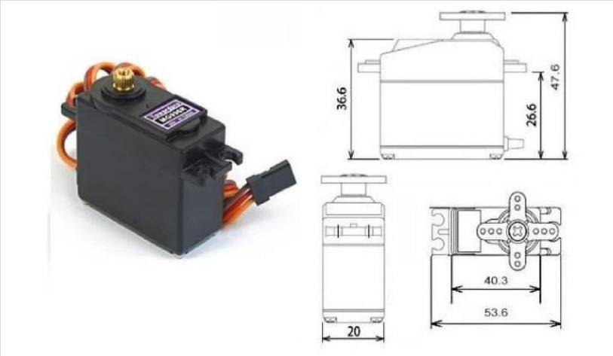

Fig - 3: MG- 966R servo motor

The High-Torque MG996R Digital Servo offers a very high 10kg stalling torque in a small package thanks to its metal gearing. With a revised PCB and IC control mechanism, the well-known MG995 servo has been upgraded with the MG996R, which is far more accurate than its forerunner. To increase dead bandwidth and centering, the engine and gearing have been modified., Most receivers, including the Futaba, JR, GWS, Cirrus, Blue Bird, and Blue Arrow, are compatible with the device's 30 cm cable and 3 pin 'S' type female header connector. Coron Berg, Spektrum, and Hitec types. This low-cost, high-torque servo can spin around 120 degrees (60 in each direction). It is perfect for novices who want to make objects move without having to construct a motor controller with feedback and gear box since you can use any servo code, hardware, or library to drive these servos, and it fits in small areas.

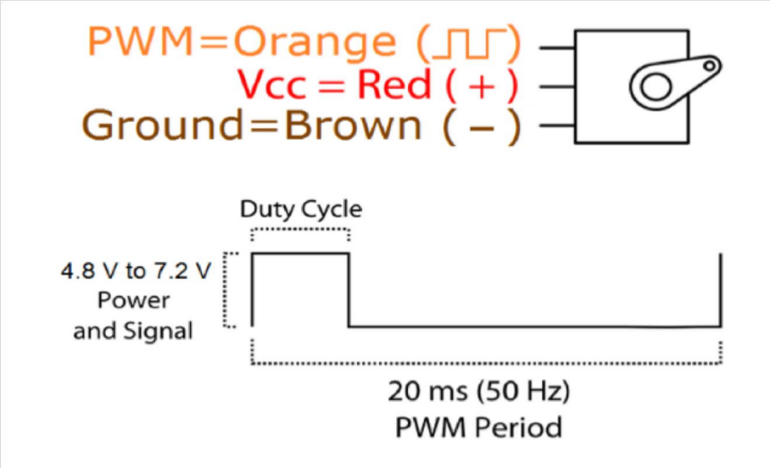

Fig - 4: pin connection

|  |  |  |
| --- | --- | --- |
| Wire number | Wire colour | Description of motor. |
| 1 | Brown | Ground wire connect to the ground of the microcontroller. |
| 2 | Red | Power to the motor  (4.8 to 7.2 v). |
| 3 | Orange | PWM signal is given through this wire to the driver to motor. |

**3.2.1 MG996R Servo Motor Features:**

• Operating Voltage is +5v typically

• Current : 2.5A (6v)

• Stall torque : 9.4kg/cm (at 4.8v)

• Maximum stall torque : 11kg/cm (6v)

• Operating speed is 0.17 s/60 degree

• Gear Type : Metal

• Rotation : 0 - 180 degree

• Weight of motor : 55g

**3.3 5V/6V Switch Mode Ultimate BEC – Voltage Regulator**

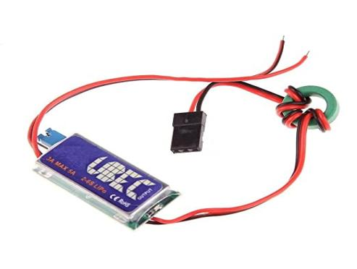

Fig - 5: BEC - Voltage Regulator

**3.3.1 Description:-**

* The voltage regulator in question is a 5V/6V 3A Switch-Mode Ultimate BEC.
* The module's innovative switch mode DC-DC regulator IC removes any concern about overheating.
* It has a strong output of 5V and 3A.
* To considerably limit electromagnetic interference, a specially designed filter is attached with the output wires and a metal shield covers nearly all of the electrical components.
* It is also perfect for RC applications because it incorporates output short circuit protection.

**3.3.3 Features: -**

* An indicator (LED) that illuminates when the output is within a normal range shows the functioning state.
* 5V or 6V (may be changed with an output-voltage choose switch) 3 Amps, continuous output current.
* Input: 5.5 to 23 volts (2 to 6 cells of lithium polymer batteries or 5 to 15 cells of NiMH or NiCd batteries).

**3.3.4 Specifications:-**

* Compatible Batteries : 2S-6s Li- PO
* Output Voltage(v): 5V
* Max. Output Current (A) : 3A
* Weight (gm) : 12gm

**3.4 24V/12V to 5V 5A Power Module DC- DC XY – 3606 Power Converter**

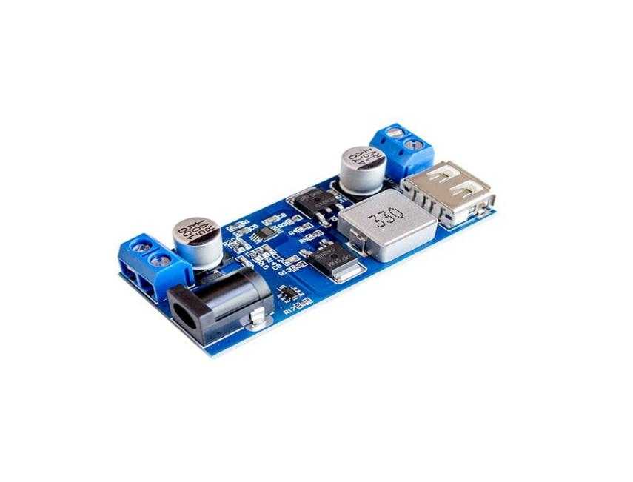

Fig - 6: DC-Dc power converter

1.Working Voltage: DC 9V – 36V

2.Output Voltage : 5.2V/5A/23W

3. 9 – 24V Input : Output 5.2V/6A/25W

4. 24 – 32V Input : Output 5.2V/5A/25W

5. 32- 36V Input : Output 5.2V/3.5A/18W

**3.4.1 Features :-**

1. Wide voltage, large current, and great efficiency describe the synchronous rectification method.
2. Simple to use using a DC plug and connections.
3. Fast-charging identification chip with USB port that is compatible with mobile phones.

**3.5 LM2596S DC – DC Buck Converter Supply**

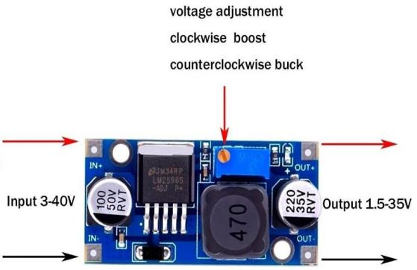

Fig - 7: DC Buck Converter

**3.5.1 Specification**:

* Input Voltage : 3 – 40V
* Output Voltage : 1.5 – 35V
* Output Current : Rated current is 2A, maximum 3A
* Switching Frequency : 150KHZ
* Operating Temperature : ( -40 + 85)
* Conversion Efficiency : 92%

**3.5.2 Description**

The DC-DC Buck Converter Step Down Module LM2596 Power Supply is a step-down (buck) switching regulator with outstanding line and load control and is capable of driving a 3-A load. These devices come with 3.3 V, 5 V, 12 V fixed output voltages as well as an adjustable output version. Because the LM2596 series switches at 150 kHz, fewer filter components are possible than with switching regulators that operate at lower frequencies.

A high-precision potentiometer and a load capacity of up to 3A may be driven by this LM2596 DC-DC buck converter step-down power module, which also has a high operational efficiency. It is compatible with the UNO as well as other mainboards and basic modules. Please attach a heat sink if the output current is higher than 2.5A (or the output power remains higher than 10W).To reduce the number of external components and streamline the power supply design, this device is internally adjusted.

In compared to common three-terminal linear regulators, the LM2596 converter's efficiency is much higher because it is a switch-mode power supply, especially at higher input voltages. Due to the LM2596's 150 kHz switching frequency, smaller filter components are possible than with switching at lower frequencies.

**3.6 Orange 4500mah 4s 35c Battery**

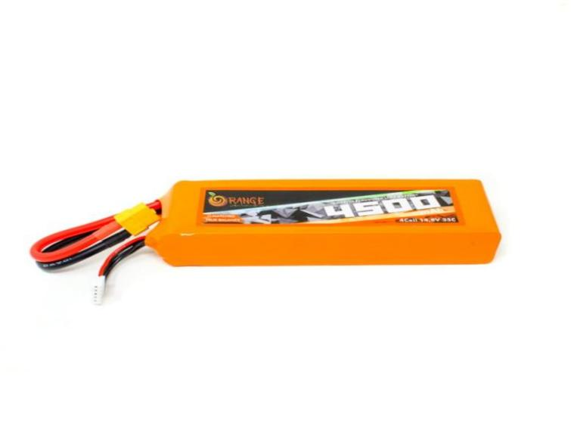

Fig - 8: Battery

### **3.6.1 Description**

The battery's orange 4500mah 4S 35C Lithium polymer battery Pack (LiPo) is renowned for its efficiency, dependability, and affordability. For those in the know, Orange Lithium polymer packs are the preferred option, which comes as no surprise to us. At a cost that everybody can afford, Orange batteries give their full rated capacity.

Heavy-duty discharge leads are included with orange 4500mah 4S 35C Lithium polymer battery Pack (LiPo) batteries to reduce resistance and support high current loads. RC vehicles and aerobatic flight both put orange batteries to the test. JST-XH style balance connectors and gold-plated connectors are included in every pack. Utilizing IR match cells, all Orange Lithium Polymer battery packs are put together.

It is a 4 cell Lipo battery . Its charged voltage is 4.2V per cell and its discharge voltage is 3.7V per cell.

**3.6.2 Sa**

**fety measures:**

* Do not subject the batteries to excessive charging or discharge.
* Do not place it near a high-temperature area.
* Don't put it in the water or the fire

**3.6.3 Specification**

* Model Number: Orange 4500mah 4s 35c
* 4500 mAh of capacity
* 14.8, output voltage (VDC)
* Balance Plug - JST - XH
* Discharge Plug - XT - 60
* Maximum Burst Discharge (c): 35C
* Dimensions: 15*5.4*4.5 cm; Length (mm): 150; Width (mm): 54; Height (mm): 43; Weight (kg): 0.489

**3.6.4 Battery Capacity Calculation**

Battery capacity 4500Mah / 4.5A

Total current require – 8.5A

**Formula**

Capacity(in Ah) = Battery life (in hours)

Load (in A)

4500 mAh = 4.5Ah

8.5A 8.5A

= 0.529h

= 32 Minutes

**Power Calculation**

**Formula**

Volts × Amp (Ah) = Watts (Wh)

14.8V × 4.5 Ah = 66Wh

**3.6.5 Efficiency of Battery**

Each cell should only discharge up to 3.3v to be safe , below this battery cell will get damage and it will never charge again.

Efficiency of battery = 3.3V × 100 % = 78%

4.2V

4500 mAh × 0.78 = 3,510 mAh ( Batter capacity we can used)

3,510 mAh

1000

= 3.51A ( Maximum current battery can supply)

**3.7 PCA 9685 Servo Driver**

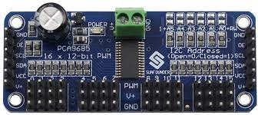

Fig - 9: PCA 9685 servo Driver

**3.7.1 Description**

A 16-channel with I2C bus management that is specially designed for Red, Green, Blue, and Amber (RGBA) colour back lighting applications is called the PCA9685 A dedicated 12-bit resolution (4096 steps) fixed frequency individual PWM controller is included in each LED output, and its operating frequency may be programmed to be between the standard 24 Hz and 1526 Hz. with a duty cycle that is changeable from 0% to 100% to enable the LED to be adjusted to a specified brightness setting. The same PWM frequency is used for each output.

Each LED output can be turned on or off (no PWM control), or changed to the value specified by its unique PWM controller. The LED output driver is set up to be either totem pole with a 25 mA sink, 10 mA source capacity at 5 V or open-drain with a 25 mA current sink capability at 5 V. The PCA9685 can operate with a supply voltage range of 2.3 V to 5.5 V and has 5.5 V-tolerant inputs and outputs.. In order to manage bigger current or higher voltage LEDs, additional drivers and a minimum number of discrete components must be used instead of connecting LEDs directly to the LED output (up to 25 mA, 5.5 V). To reduce current spikes, the PCA9685 supports staggered LED output on and off periods. Each of the 16 channels has an individually programmed on/off time delay. PCA9635 does not have this functionality.

• The PCA9685 can adjust each individual LED's brightness in 4096 steps (12-bit PWM). There are only 256 steps in the PCA9635 (8-bit PWM).

• If PCA9635s are employed, the PWM pulse widths across various devices in a system with numerous LED controllers may vary. A programmable prescaler on the PCA9685 allows users to modify the PWM pulse widths of several devices. In place of its inbuilt 25 MHz oscillator, the PCA9685 features an external clock input pin that may receive user-supplied clock (up to 50 MHz). Multiple devices can be synchronized thanks to this capability. The PCA9685 contains an integrated oscillator for PWM control, much like the PCA9635. of contrast to the standard 97.6 kHz frequency of the PCA9635, the frequency utilized for PWM control of the PCA9685 is changeable from around 24 Hz to 1526 Hz. As a result, PCA9685 can be used with external power supply controllers. The same frequency has been set for each bit.

• In the instance of PCA9685, the LEDn output pins' Power-On Reset (POR) default state is LOW. For PCA9635, it is HIGH. The LED may be controlled in asynchronous fashion by the active LOW Output Enable input pin (OE). It is possible to utilise the outputs to set each output to a specific I2C-bus programmable logic state. Additionally, the OE may be used to 'pulse width modulate' the outputs externally, which is beneficial when a software controller is required to dim or blink many devices simultaneously. Controllable via software LED The three Sub Call and All Call I2C-bus addresses allow all PCA9685 devices to respond to a single I2C-bus address, allowing features like marquee. chasing or the simultaneous on/off of all red LEDs while also reducing the number of I2C-bus requests. With just six hardware address pins, 62 devices may share a single bus.

Similar to the Power-On Reset (POR), which sets the outputs to LOW and initializes the registers to their default state, the Software Reset (SWRST) General Call enables the master to reset the PCA9685 using the I2C-bus. This makes it possible to quickly and easily software-reconfigure all device registers to the same state.

**3.7.2 Feature and Benefits**

* sixteen LED drivers. Each output may be set to operate in one of the following modes: Off, On, Programmable LED Brightness, and Programmable LED Turn-On Time to Help Reduce EMI.
* I2C-bus interface with a 30 mA high drive capacity on the SDA output that is compatible with Fast-mode Plus at 1 MHz for driving high capacitive buses.
* From entirely off (default) to maximum brightness, each LED output has a 4096-step (12-bit) linear programmable brightness control.
* The standard value of 1Eh in the PRE_SCALE register produces a 200 Hz refresh rate with a 25 MHz oscillator clock; the output frequencies of all LEDs typically range from 24 Hz to 1526 Hz.
* 16 totem pole outputs with software-programmable open-drain LED output option (totem pole default) (sink 25 mA and source 10 mA at 5 V). no input capability.
* To update outputs byte-by-byte or all at once, output state change can be programmed on the Acknowledge or STOP Command (the default is "Change on STOP").
* To update outputs byte-by-byte or all at once, output state change can be programmed on the Acknowledge or STOP Command (the default is "Change on STOP").
* 62 PCA9685 devices can be linked to the same I2C-bus using the 6 hardware address pins. Hardware LED flashing is made possible by toggling OE.
* One LED All Call address and three LED Sub Call addresses provide four software-programmable I2C-bus addresses that enable groups of devices to be addressed simultaneously in any configuration (for instance, one register is used for "All Call" so that all PCA9685s on the I2C-bus can be addressed simultaneously, and the second register is used for three different addresses so that one-third of all devices on the bus can be addressed simultaneously in a group). These I2C-bus addresses provide software enable and disable options.
* The device may be reset using the I2C-bus thanks to the Software Reset functionality (SWRST General Call).
* A typical internal oscillator operating at 25 MHz needs no extra components.
* Edge rate control on outputs; an external clock input of up to 50 MHz; an internal power-on reset; and a noise filter on the SDA/SCL inputs.
* Low standby current, 5.5 V tolerant inputs, 2.3 V to 5.5 V operating power supply range, no output glitches upon power-up, support for hot insertion
* 40 to 85 degrees Celsius operation
* ESD protection is greater than 2000 V HBM per JESD22-A114, 200 V MM per JESD22-A115, and 1000 V CDM per JESD22-C101. Latch-up testing is performed in accordance with JEDEC Standard JESD78, which is greater than 100 mA.

**3.6.3 Block Diagram**

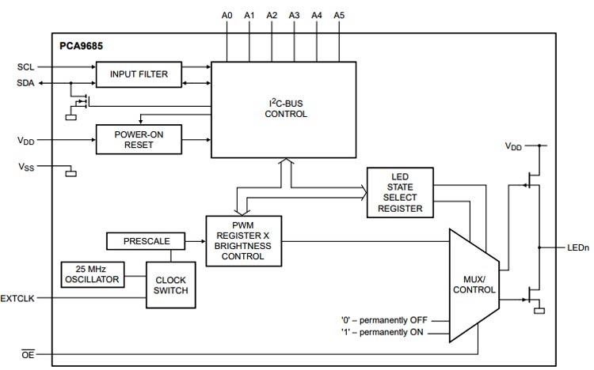

Fig - 10: Block Diagram of PCA 9685

**3.7.4 Pinning Information**

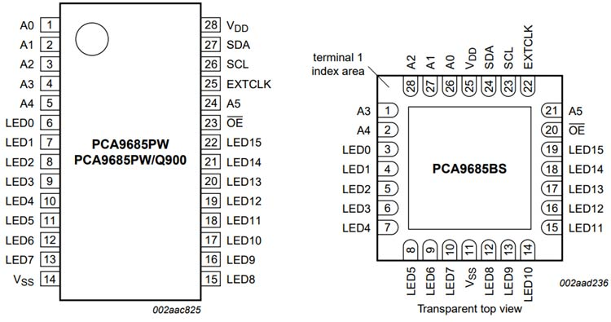

Fig - 11 : PCA 9685 Pinouts

3.7.4.1 PCA9685 Pin Configuration

|  |  |  |
| --- | --- | --- |
| Pin No | Pin Name | Pin Configuration |
| 1 | A0 | Input address 0 |
| 2 | A1 | Input address 1 |
| 3 | A2 | Input address 2 |
| 4 | A3 | Input address 3 |
| 5 | A4 | Input address 4 |
| 6 | LED0 | Led driver 0 |
| 7 | LED1 | Led driver 1 |
| 8 | LED2 | Led driver 2 |
| 9 | LED3 | Led driver 3 |
| 10 | LED4 | Led driver 4 |
| 11 | LED5 | Led driver 5 |
| 12 | LED6 | Led driver 6 |
| 13 | LED7 | Led driver 7 |
| 14 | Vss | Supply ground |
| 15 | LED8 | Led driver 8 |
| 16 | LED9 | Led driver 9 |
| 17 | LED10 | Led driver 10 |
| 18 | LED11 | Led driver 11 |
| 19 | LED12 | Led driver 12 |
| 20 | LED13 | Led driver 13 |
| 21 | LED14 | Led driver 14 |
| 22 | LED15 | Led driver 15 |
| 23 | OE | Active low output enable |
| 24 | A5 | Input address 5 |
| 25 | EXTCLK | External clock input |
| 26 | SCL | Serial clock line |
| 27 | SDA | Serial data line |
| 28 | VCC | Supply voltage |

**3.7.5 Applications**

* Drivers for RGB or RGBA LEDs
* status information for LEDs
* LCD backlight versus LED displays
* Cellular phone or portable device keypad backlight

**3.84 channel 5V Relay Module**

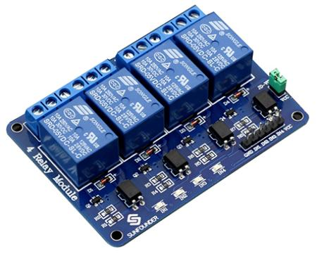

Fig - 12: Relay module

This 4-channel, 5V relay interface board needs a 15-20mA driving current for each of its channels.. It may be used to operate a variety of high-current devices and appliances. It has high-current relays that operate at either AC250V or DC30V 10A. It features a common interface that a microcontroller may directly operate . The relay is the device that turns on or off the contacts so that the other electric control is turned on.. It recognizes an unfavourable state in a designated area and instructs the circuit breaker to disconnect the problematic region by turning it ON or OFF.

Every Electromagnetically relay consists of

1. Electromagnet  
3. Mechanically movable contact  
3. Switching points and  
4. Spring

COM : common pin

No : Normally open - The common pin and the typically open pin don't make contact with one another. As a result, the load receives power when the relay is triggered since it is connected to the COM pin.

**NC :** Normally closed – The common pin and the usually closed pin are in touch. Even when the relay is off, there is always a connection between the COM and NC pins. The circuit is opened and the load is not supplied with power when the relay is triggered.

**3.8.1 Functioning of relay module**

It functions on the idea of electromagnetic attraction. The electromagnetic field that creates the temporary magnetic field is energized when the relay's circuit detects the fault current. The relay armature is moved by this magnetic field to open or close connections. The high power relay has two contacts for opening the switch, compared to the small power relay's single contact. The figure below depicts the relay's interior part. It features a control coil twisted around an iron core. The concept of electromagnetic attraction underlies its operation. When the relay's circuit detects the fault current, the electromagnetic field that generates the temporary magnetic field is activated. This magnetic field moves the relay armature, opening or closing connections. In contrast to the small power relay's single contact, the high power relay includes two contacts for activating the switch. The inside of the relay is shown in the diagram below. It has an iron core with a control coil wrapped around it.

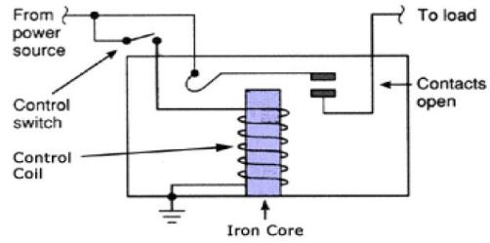

Fig - 13: internal relay circuit

**3.8.2 Types of Relay Based on the principle of operation**  
1. Electrothermal relay  
2. Electromechanical relay  
3. Solid State relay  
4. Hybrid relay

****3.8.3 Applications of relay module****

* For the protection of ac and dc equipment, they may be utilized with both systems.
* B. It is also conceivable for electromagnetic relays to function at rates of up to one millisecond.
* They have the properties such as simple, robust, compact and most reliable.
* These relays nearly happen instantly. Although instantaneous, the relay's operation time changes depending on the current. copper rings, as well as other configurations like dash pot.

**3.8.4 Disadvantages**

A. Instrument transformers with a high level of load are necessary.

B. Requires periodic maintenance and testing unlike static relays.  
C. Dust, pollution, and component ageing all have an impact on relay operation and can cause erroneous trips.

E. The mechanical inertia of the component governs how quickly electromagnetic relays may operate.

**3.8.5 Specification**

* Digital output controllable
* Compatible with any 5V microcontroller such as Arduino.
* Rated through-current: 10A (NO) 5A (NC)
* Control signal: TTL level
* Max. switching voltage 250VAC/30VDC
* Max. switching current 10A
* Size: 76mm x 56m

**3.9 Acrylic sheet**

For designing a Robot body, we are using Acrylic sheet . Acrylic sheet nothing but it is a translucent plastic with exceptional strength, rigidity , and optical clarity is acrylic. Acrylic sheet is simple to manufacture , adheres well to solvents and adhesives, and adhesives, and is simple to thermoform. Compared to many other transparent plastics, it offers better weathering characteristics. Clarity , brightness and transparency of acrylic sheet are comparable to those of glass.



Fig - 14: Acrylic sheets

Properties and Application of Acrylic sheet

1. It is hard and light weight.
2. It is flexible.
3. Excellent optical clarity and transparency.
4. Extremely resistant to many different chemical.
5. Highly resistant to variation in temperature.

**3.10 Suction motor**

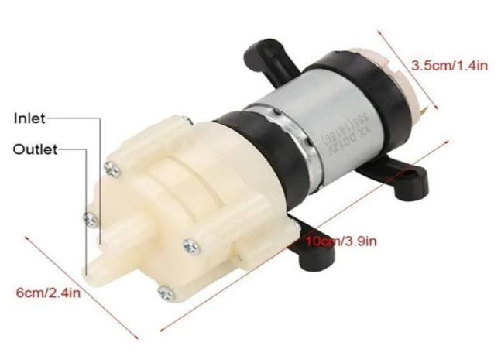

Fig - 15: suction motor

One of the most vital components of a cleaner is the suction motor. This motor is in charge of transforming energy into mechanical energy in the form of suction and air flow.

A suction motor, also known as a diaphragm pump, contains two parts inlet and outlet. We are connecting to a inlet point for suction motor so that vacuum cups can stick to the wall and hold a robots body . As we increase the current in the suction motor, it will suck more vacuum.

**3.10.1 Specification**

* Working voltage - DC 6V - 12
* Working current - 1A ( power must achieve 6w above)

**3.11 Suction cup**

A suction cup, often called a sucker, is a tool or object that adheres to nonporous surface by using the negative fluid pressure of air or water to create a partial vacuum.

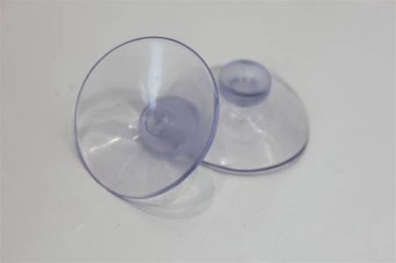

Fig - 16: suction cup

We are using a suction cup to holds a robot legs with a help of a suction motor. Suction cups are capable of holding an approximation weight of 4kg.

**3.11.1 Working of suction cup**

The suction cup’s working face is comprised of an elastic, malleable substance and has a cured surface. When the substance cups center is pressed up again a smooth , non-porous surface, the volume of the gap between them is reduced ,which allow any air or liquid to be tapped there to be forced out past the circumference and the majority of the fluid having already been driven of the cups . Due to a lack of pressure and the majority of the fluid having already been driven out of the cups interior, the cavity that forms between the cup and the flat surface contains little no water or air the differential in pressure between the low pressure environment outside the cup and the atmosphere inside.

**3.12 Jumper wires**

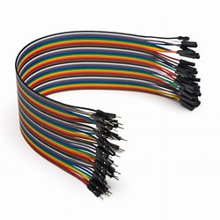

Fig - 17: jumper wires

An electrical wire, or set of them in a cable, with a connector or pin at each end is referred to as a jump wire. It is typically used to connect the parts of a breadboard, other prototype circuit, or test circuit internally or with other pieces of machinery or components without soldering.

The "end connectors" of each jump wire are fitted by sliding them into the slots on a breadboard, the header connector of a circuit board, or a piece of test equipment.

**3.13 Connection of suction motor with Relay and Arduino Mega**

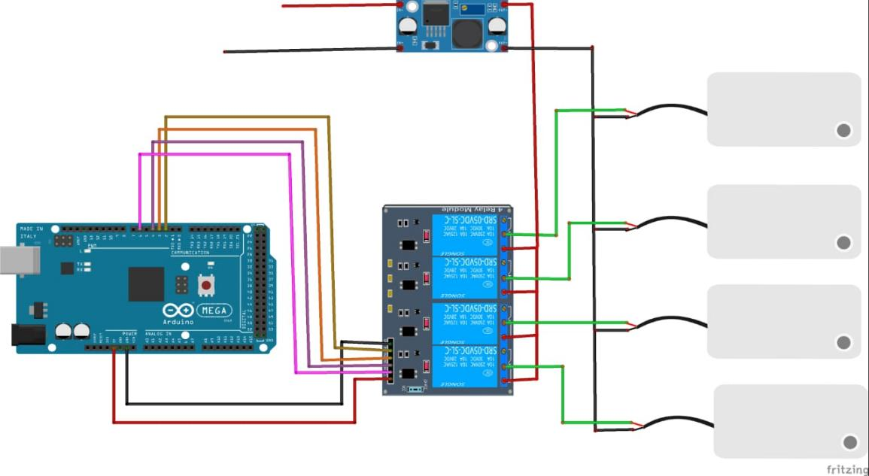

Fig - 18: Connections of suction motors

Connection of the circuit diagram shown above. Relay modules consist of four channels, operate on 5 volts, and can handle four suction motors.

* 5 volts of the relay module go to 5 volts of the Arduino Mega Pin.
* The negative pin of the relay module goes to the negative Arduino Mega pin.
* IN 1 of the relay module goes to pin 2 of the Arduino Mega.
* IN2 of the relay module goes to pin 3 of the Arduino Mega.
* IN 3 of the relay module goes to pin 4 of the Arduino Mega.
* IN 4 of the relay module goes to pin 6 of the Arduino Mega.
* All the negatives of the suction motors go to the negative of the power supply.
* All the positives of the suction motors go to the normally open relay module and also go to the positive of a power supply.

**CHAPTER 4**

**METHODOLOGY:**

**4.1 SYSTEM BLOCK DIAGRAM:**

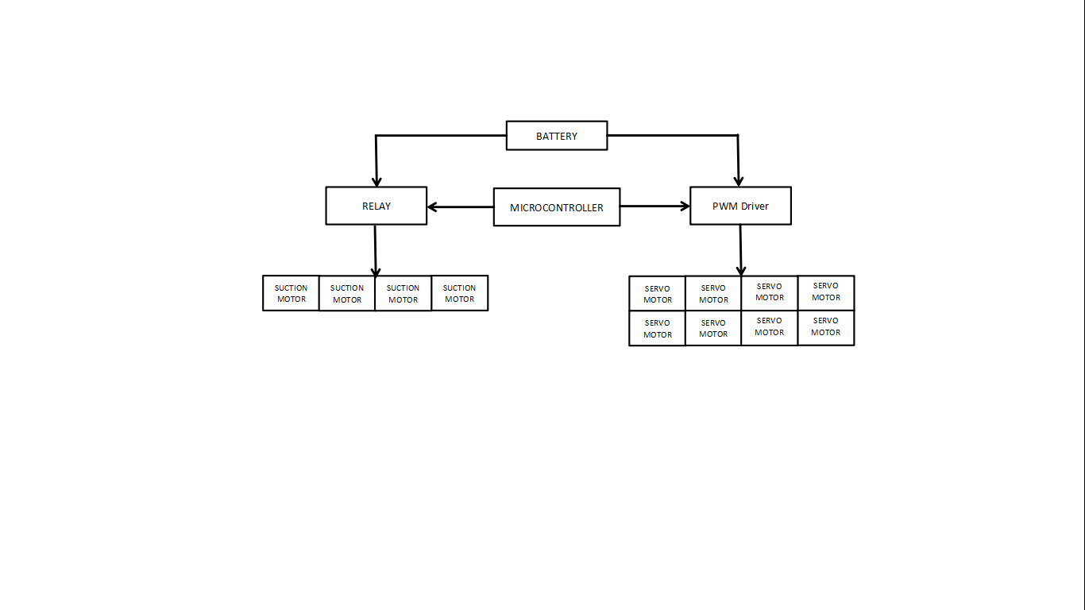

Fig - 19: Block Diagram

The pictorial description of the project design is shown in the fig-19 This is a battery based system consist of 4 channel relay module, 4 suction motor , PWM driver circuit, 8 servo motor interfaced to Arduino Mega Micro-controller. As depicted in the diagram the relay will be controlled by the controller which will in-turn control the functioning of the suction motors. Similarly all the eight servo motors will be controlled by the controller through the PWM driver. In order to supply the desired voltages to the different parts of the circuit the Switch Mode Ultimate BEC – Voltage Regulator, 12V to 5V 5A Power Module and LM2596S DC – DC Buck Converter Supply are used.

**4.2 Experimental Setup**

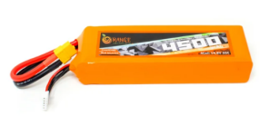

**Capture**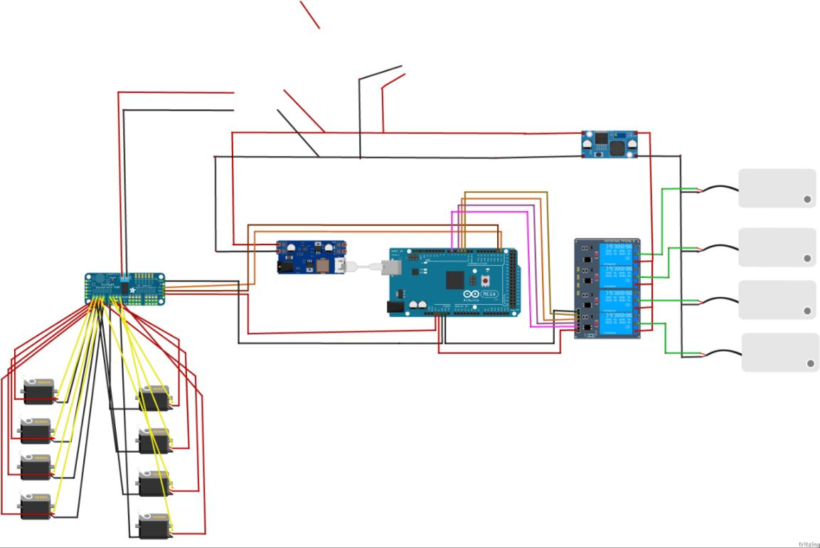

Fig - 20 : Circuit Diagram

The entire experimental setup of the robotic structure has been elaborated in fig-20. The system being battery operated the entire power consumption is taken care by the battery module, Orange 4500mah 4s 35c (lipo battery). As the voltage requirement varies for the different modules in the circuitry, different intermediate modules are used. For example the voltage requirement of suction motors are 9v which is obtained by using LM2596S DC – DC Buck Converter Supply. Future the voltage required by PCA9685 driver circuit for driving the servo motors is obtained by using 5V/6V Switch Mode Ultimate BEC – Voltage Regulator and 12V to 5V 5A Power Module is used to supply the necessary voltage need by the Arduino mega.

It can be seen from the diagram that the suction motors are connected to the 4 channel relay module which will perform the function of holding the grip on the surface. The Ground of Arduino mega and relay module are connected together and the Vcc of the relay module is connected to the 5v. Further relay 1, relay 2, relay 3 and relay 4, are connected to the pin no 2, 3, 4, and 6 of the Arduino mega respectively in order to establish the interface between the two modules.

The Servo motors are controlled by Arduino mega and powered through PCA 9685 driver circuit via pins 0 to 7. The ground of PCA 9685 driver circuit and of Arduino Mega is connected together and Vcc of PCA 9685 driver circuit is connected to the 3.3v pin on Arduino Mega. SCL and SDA pins from Arduino Mega are connected to

**4.3 Robotic Schematic**

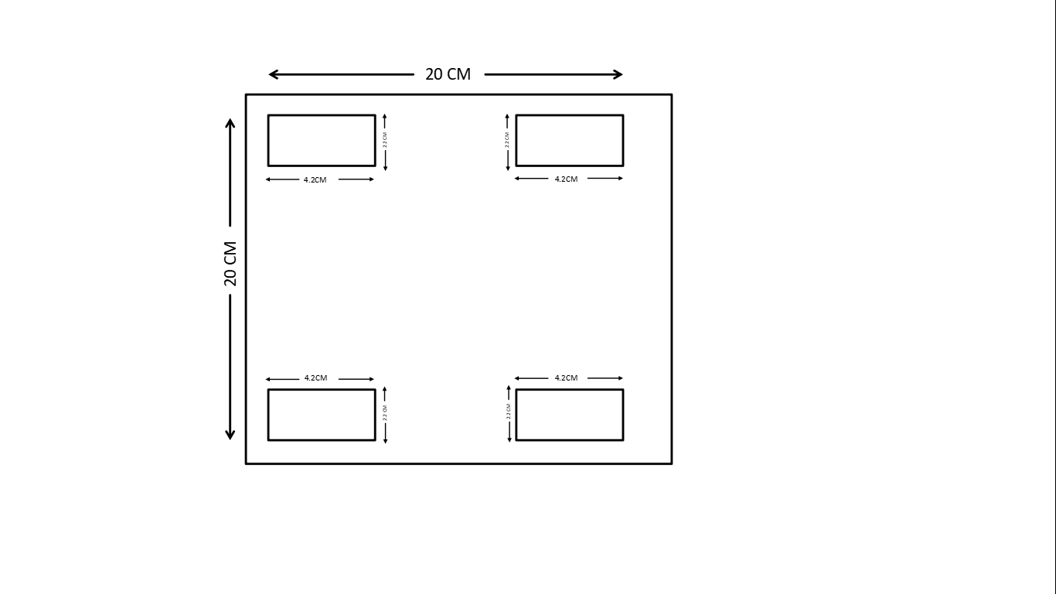 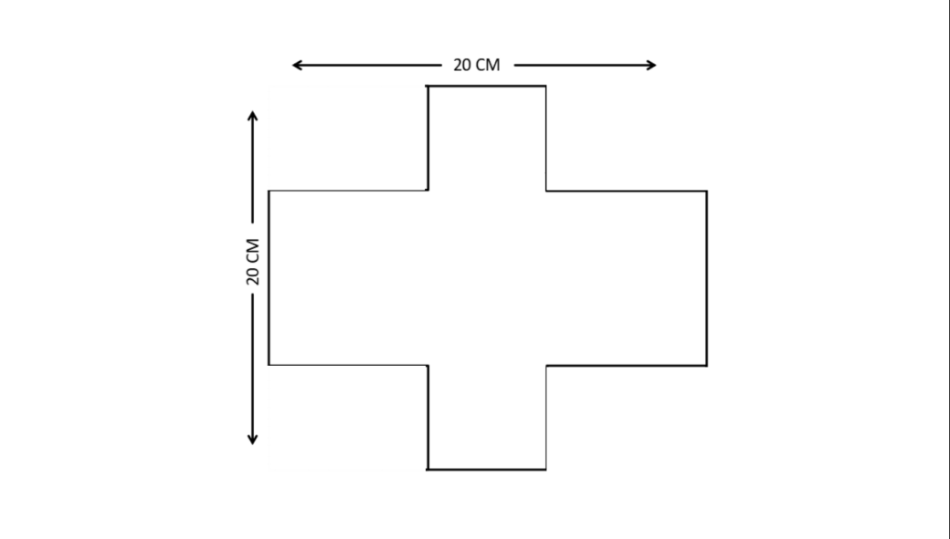

**Fig- 21.A:** Robotic Base Structure **Fig- 21.B:** Intermediate Layer

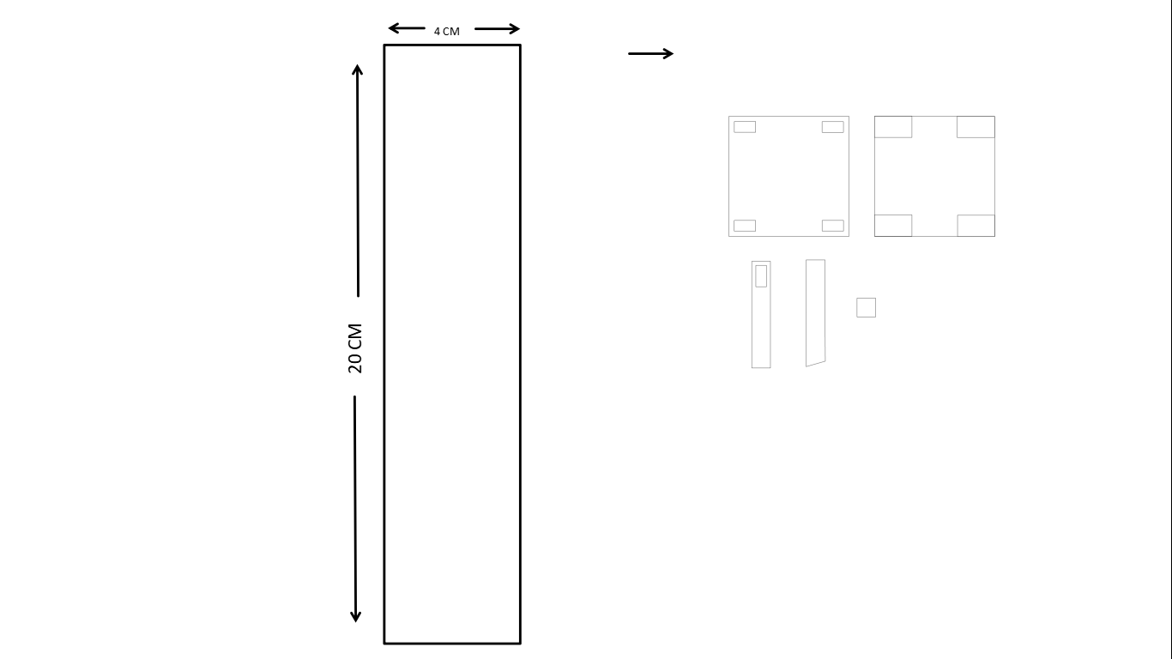 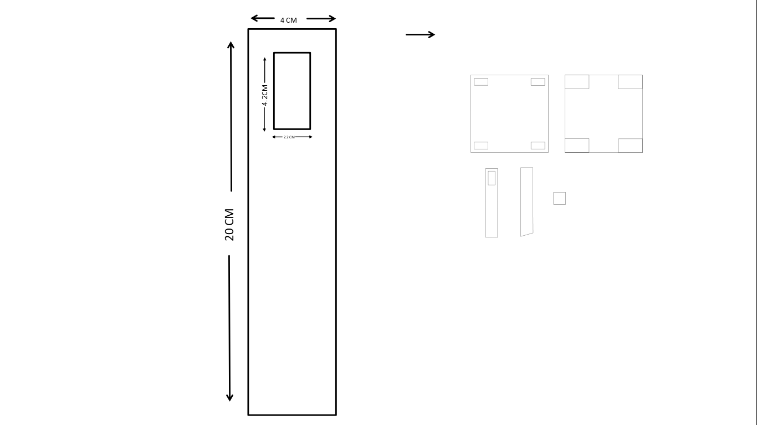

**Fig- 21.C:** Internal Arm **Fig- 21. D:** External Arm

**Fig-21.A** forms the base of the robotic structure on which 4 servo motors, 4 suction motors and a battery is mounted. The servo motors controls the internal arms of the robot, whereas the suction motors hold the grip through suction cups placed on the external arm. The intermediate layer structure is shown in **Fig-21.B** which is mounted on the top of the robotic base structure. The Arduino Mega, PCA 9685 driver circuit module, LM2596S DC – DC Buck Converter Supply module, 5V/6V Switch Mode Ultimate BEC – Voltage Regulator and 12V to 5V 5A Power Module are placed on this intermediate layer. **Fig-21.C** shows the Internal arm which connects to the servo motors on the robotic base and also to the motors placed at the junction of the external and internal arm.The external arm is shown in the **Fig-21.D**, on which the servo motors are mounted on one end (at junction of external and internal arm) and suction cups on the other end.

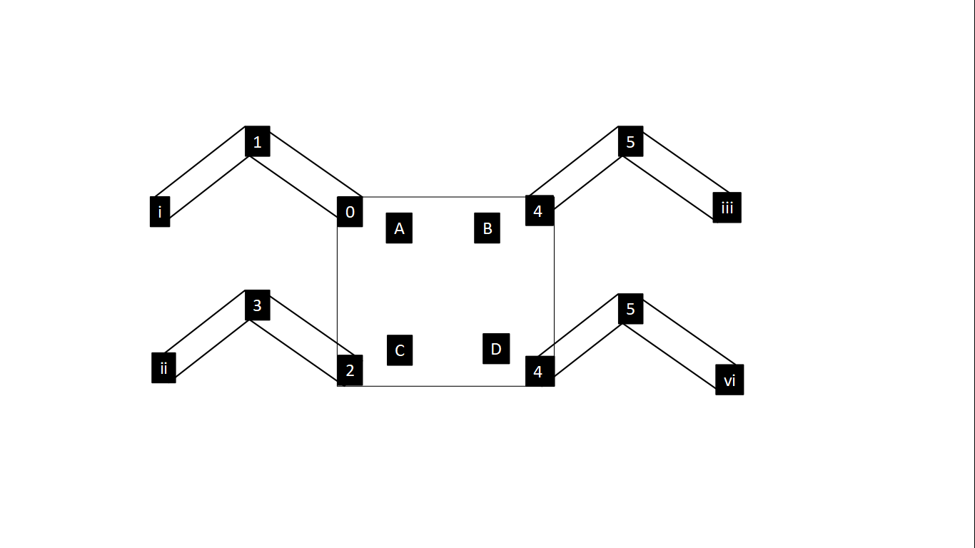

**Fig- 21.E:**  Full structure

The final schema of the robot comprising of all the parts described above is shown in **Fig- 21.E**.

**4.4 Working**

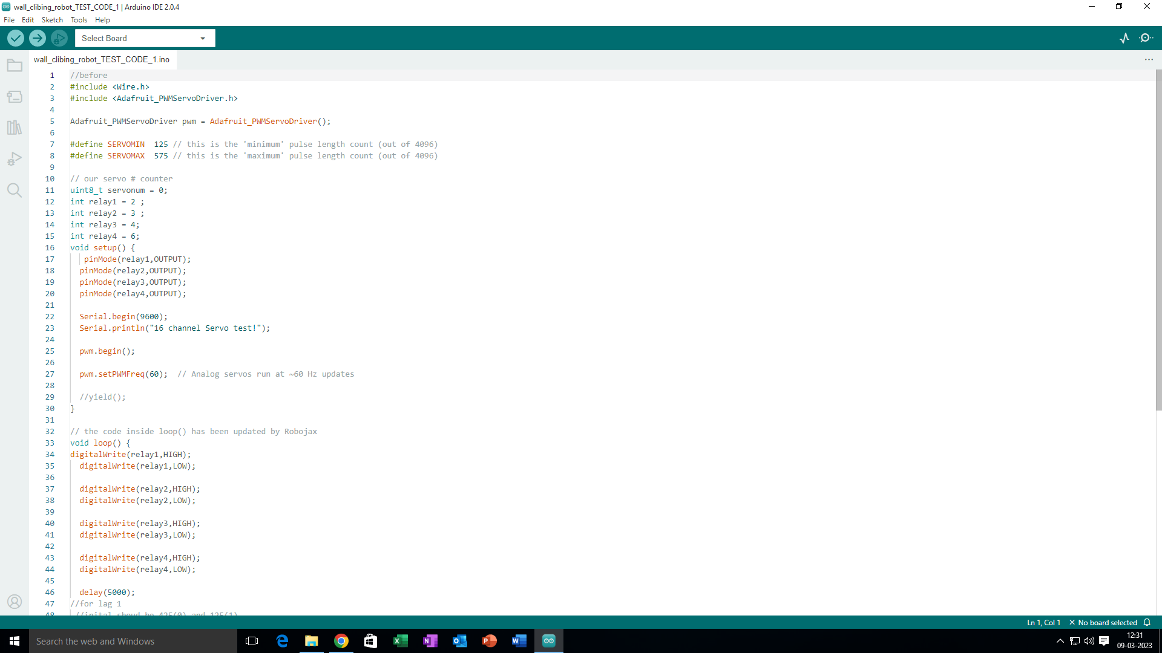To understand the working first we have to understand code which is design to control robots movements. In the code we defined minimum and maximum pules as 125 and 575 respectively.

Fig - 22: Code for minimum and maximum pulses

**4.4.1 For Left side of Robot**

Let us assume in fig 22 that pule 125 is equal to 0° and 575 is equal to 180°.

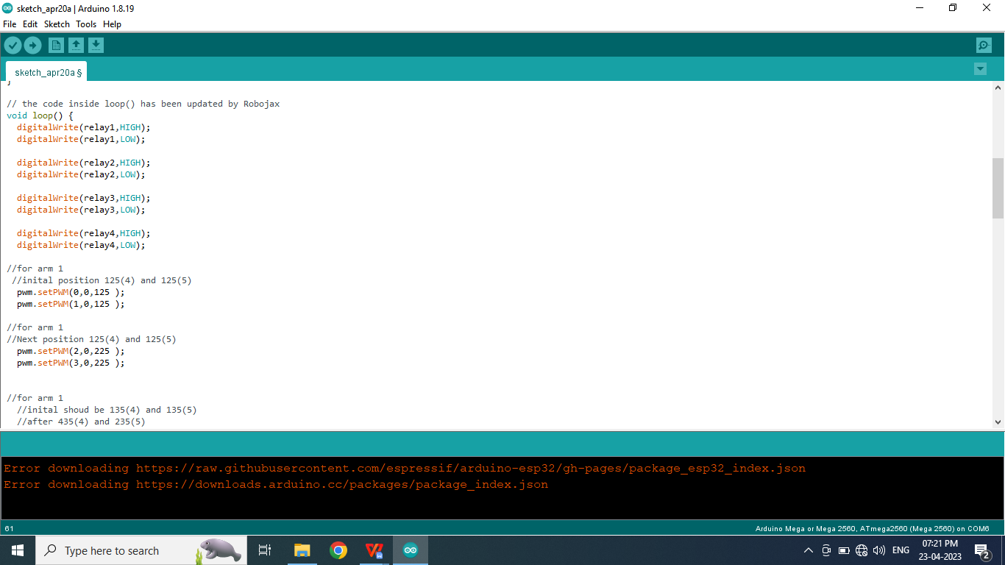

Fig - 23 : code for set pluses

For the initial position we set angle to 70° which is equal to 125 pulse of PWM. And for the next position the angle set at 78° which is equal to 225 pulse of PWM. To the angle moves from 70° to 78°. For better understanding take a look at fig-22.

Next Position

Initial Position

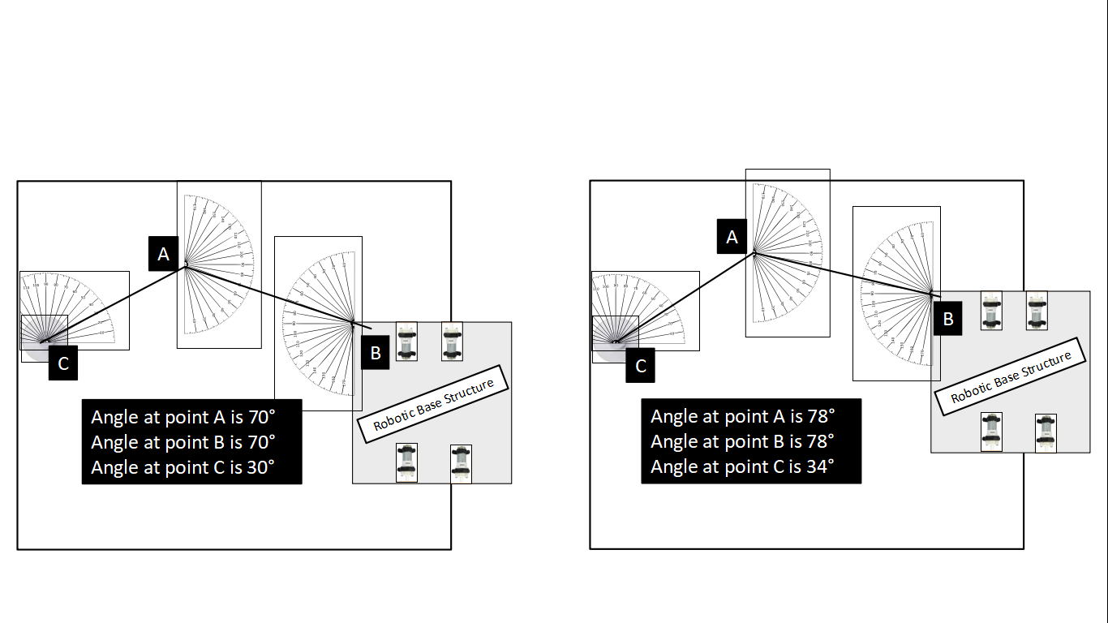 

Fig - 24: Angle of Arms from initial to next position

**4.4.1.1 Initial Position**

Servo motor is mounted at point B and A and suction cup is at point C of external arm. The angle in initial position at point A and B is 70° and at point C is 30°.

**4.4.1.2 Next Position**

In the Next position, servo mover at point B will change its angle from 70° to 78°. At the same time servo motor at point A will also change its angle from 70° to 78°. while servo motors changing its angles, point C where suction cup is mounted will also change its angle from 30° to 34° .

**4.4.2 For Right side of Robot**

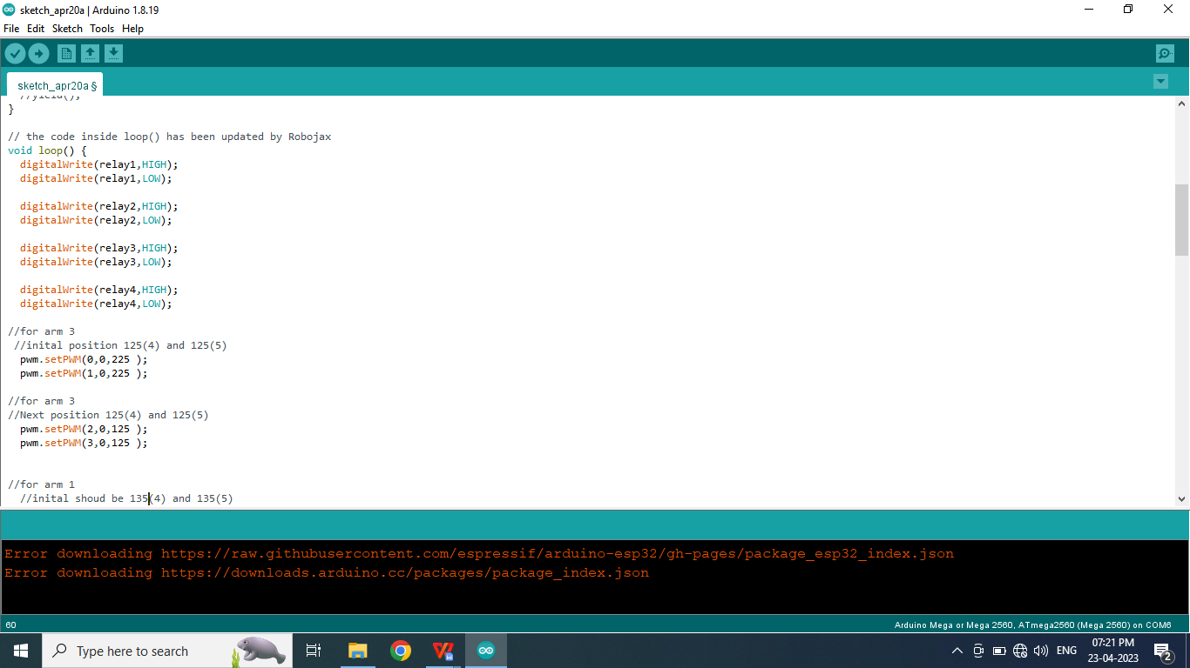

Fig - 25: code for set pluses

For the right side of the robot every thing will remain the same but the angle will be opposite to which we mention for left side of robot that is first pulse will be 225 at both the servo motors which will change to 125 after movement .

**4.4.3 Initial Position to Next Position**

Let us understand the by looking at Fig4.4.3.1 how the robot robot will mover from initial position to next position. In the Fig 4.4.3.1

* servo motors are 0,1,2,3,4,5,6,7
* Suction motor are A,B,C,D
* Suction Cups are a,b,c,d

Initial Position

Next Position

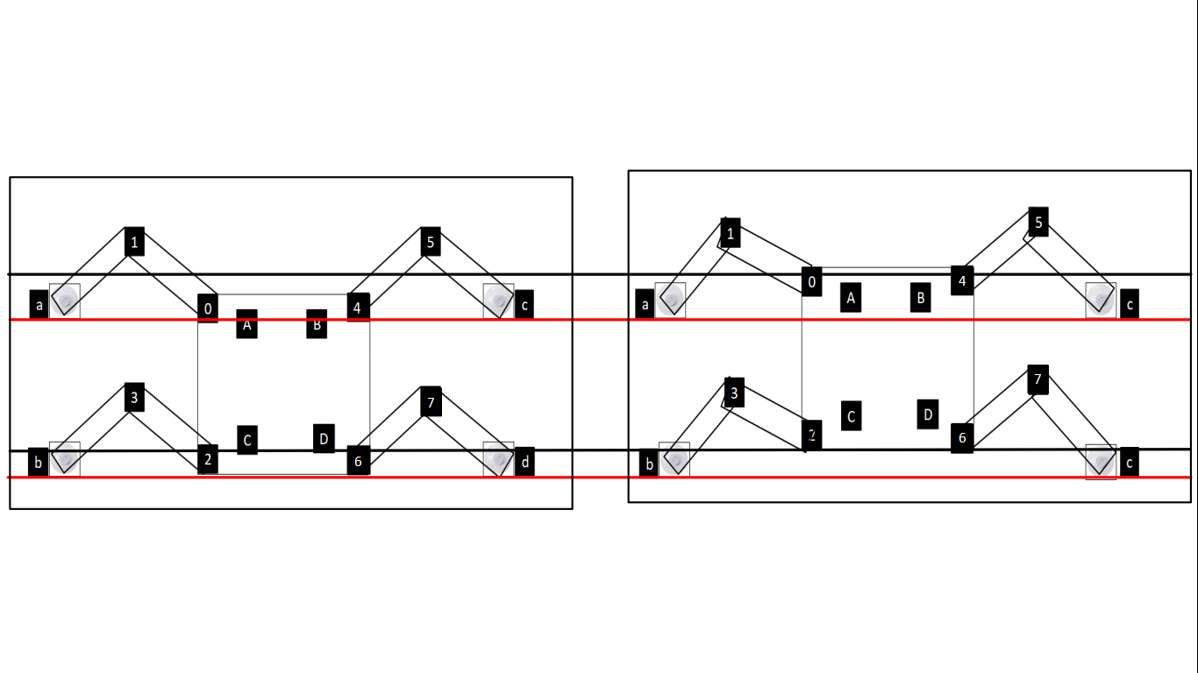

Fig -26: From initial to next position

In the Fig-26 there are two lines red and black which indicate initial and next position. First the robots body is touching red line in the initial position and after the movement of the servo motors (0,1,2,3,4,5,6,7) It will move forward (next position) and touching black line. Also angles will change at suction cups (a,b,c,d).

After the next potion Suction Motor ‘A’ will stop for few seconds so that suction cup ‘a’ will released from the surface and Servo motors ‘0’ and ‘1’ will change its angle to initial position and Suction motor ‘A’ will turn ON and suction cup ‘a’ will stick to the wall again. After this, Suction motor ‘B’ will stop and servo motors ‘2’ and ‘3’ will change its angle to initial position and suction motor ‘b’ will turn ON. This process will repeat for all 4 arms of the robot. And finally the robot will come to the initial position, Next all four suction motor (A,B,C,D) will turn ON and suction cups (a,b,c,d) will hold to the wall and servo motors (0,1,2,3,4,5,6,7) will change its angle and bring robot to the next position. This moment flow can be seen in the fig- 28.

**4.5 Algorithm**

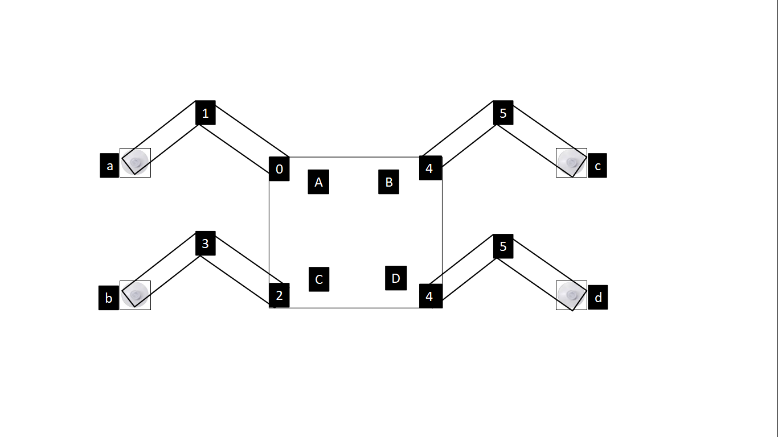

Fig - 27: Design of robot

1. Start
2. Bring all the arms to t he initial position and turn all suction motor ON.
3. Change angles of Servo motors (0,1,2,3,4,5,6,7) and bring robot it in next position.
4. Turn off suction motor ‘A’.
5. Change angle of servo motor ‘0’ and 1’ and bring it to initial position.
6. Turn On suction motor ‘A’.
7. Turn off suction motor ‘C’.
8. Change angle of servo motor ‘2’ and 1’ and bring it to initial position.
9. Turn On suction motor ‘C’
10. Turn off suction motor ‘B’.
11. Change angle of servo motor ‘4’ and 5’ and bring it to initial position.
12. Turn On suction motor ‘B’
13. Change angle of servo motor ‘6’ and 7’ and bring it to initial position.
14. Turn On suction motor ‘D’
15. Repeat from step 3
16. Stop

**4.6 Flow chart**

Start

Change angle of servo motor ‘6’ and 7’ and bring it to initial position.

Turn off suction motor ‘D’.

Turn On suction motor ‘B’

Change angle of servo motor ‘4’ and 5’ and bring it to initial position.

Turn off suction motor ‘B’.

Turn On suction motor ‘C’

Change angle of servo motor ‘2’ and 1’ and bring it to initial position.

Turn off suction motor ‘C’.

Turn On suction motor ‘A’

Turn off suction motor ‘A’.

Change angle of servo motor ‘0’ and 1’ and bring it to initial position.

Bring all the arms to the initial position and turn all suction motor ON.

Change angles of Servo motors (0,1,2,3,4,5,6,7) and bring robot it in next position.

Change angle of servo motor ‘2’ and 1’ and bring it to iitial position.

Turn On suction motor ‘D’

Stop

Fig - 28: Flow chart

**4.7 Challenges in Developing wall Climbing Robot**

Designing of the robot body was difficult because the design was totally new of its kind. First we design robot using aluminium body but the cutting aluminium in proper shapes was difficult. Later we use acrylic sheets, where design can drawn in coral draw software and acrylic sheets can be using LEASER technology.

First we use Tower Pro SG90 servo motor, but to its low torque we have switch to MG996R servo motor. Next to do the movement of the arms was a most difficult task for us because for 1 arm we are controlling two servo motors where angle should be at exactly opposite to each other. And finding the proper angle was a big task. For that we continuously tested different angles and finely we got the proper angles. Next task use of suction motor and suction cups, which stick to the wall and hold the weight of the robot. First suction cups was not sticking properly to the surface. So we try using different suction cups of bigger size and also increase the the power so suction motor. Next was to give power for different component which required different voltage through 14v battery. This problem was solve by using step down circuit like Switch Mode Ultimate BEC – Voltage Regulator, 12V to 5V 5A Power Module  and LM[2596](C:/Users/Prajyot/Desktop/New%20folder/tel:2596)S DC – DC Buck Converter Supply.

**4.8 Result & Conclusion**

As per the schematic design the wall climbing robot was developed using acrylic sheets. On the base structure of the robotic body was mounted with 4 servo motors, 4 suction motors and battery. Here the suction motors were fixed using nut-bolt, PCA[9685](C:/Users/Prajyot/Desktop/New%20folder/tel:9685) driver circuit was mounted, battery was placed between servo motors and tied using cable tie. The servo motors were stick using acrylic sticking glue also know was industrial stick-fast. On the top of this base layer, the intermediate layer was place and fixed using glue. On this intermediate layer  Arduino mega [2560](C:/Users/Prajyot/Desktop/New%20folder/tel:2560), 4 channel relay module, Switch Mode Ultimate BEC – Voltage Regulator, 12V to 5V 5A Power Module  and LM[2596](C:/Users/Prajyot/Desktop/New%20folder/tel:2596)S DC – DC Buck Converter Supply were mounted. Further the servo motor and suction cups were fixed to the external arms of the robot arm and internal arm were connected with servo motors on both the sides.  
  
The connection were made as per the circuit  diagram. After successfully assembly of the hardware  the software part was implemented i.e. for programming the movements of servo motor and controlling of suction motor Arduino IDE was used.  
  
The designed robot successfully follows the movement instructions and the suction cups holds its grip. This designed robotic structure is a prototype of quadruped  robot which have 4 legs and 2 joint for each legs which can moves forward direction.

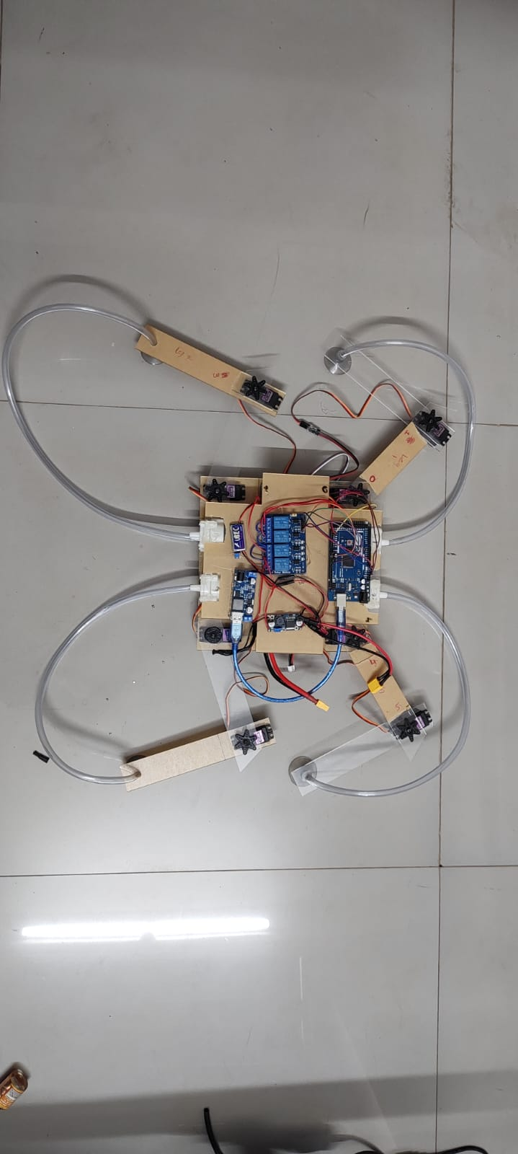

Fig - 29: Designed wall climbing robot

**CHAPTER 5**

**Future Advancement**

Wall-climbing robots have a broad range of applications. This robot will be able to do jobs considerably more effectively in the near future. The only limit to its potential applications is your imagination. It has the potential to be a huge benefit to everyone. The robot may be taught to respond to human commands and complete tasks. It is also conceivable to have a precise gesture-controlled system.

1. The servo motors and suction motors' speeds can be raised to minimize the robot's working time. As the working time lowers, the task assigned to the robot will be performed considerably faster.
2. It is critical that the robot be adaptable. As a result, in the near future, we will be able to make the robot function on varied surfaces with ease while maintaining its efficiency. To do this task, we may also enhance the battery capacity, allowing the robot to function for extended periods of time
3. Because it is a wall-climbing robot, the weight of the robot must be decreased to allow it to scale vertical surfaces more easily and faster.
4. If we redesign suction cups and develop suction cups that can stick inside of water tank, robot can also we using for cleaning water tanks.
5. Vacuum pump can be mounted on the robot that can suck the dust from the walls also side and roller brush can be use to remove dust.
6. Mostly our wall have photo farms, clocks, LED TV, etc. That need to detect. To do so we need to add ultrasonic or IR sensor or combination if both sensor to all 4 side of the robot to detect the obstacles.Using the sensors allows the robot to work more effectively.
7. Further, LIDAR sensor can be place on the robot which will create 2D map of the wall and by using smart algorithm, robot can find efficient cleaning path. Also it can differ between photo frame or calender or other objects.
8. Robot can be integrated with mobile application, so the it can be control using the mobile phone and comment can be given to the robot to go to the specific area and do its task.
9. Arrangement can be made by changing some parts of design, robot can climb over a high-ted path of about 4cm to 8cm for example tube light. Also IR sensor can be placed at the bottom of the robot so that it can detect the distance between walls and robot body, which will help the robot to detect, whether the wall is about to end.
10. Insects like lizard and cockroaches etc are mostly on the walls and to detect it we can use camera along with 3D dept sensor to detect unwanted obstetrical and change the direction.
11. For the charging part, charging dock can be installed on the wall where robot can go automatically and recharge its battery. To calculate the reaming charging time and distance between robot current position and charging dock , 2D map along with marching learning can be use.

**CHAPTER 6**

**REFERENCE**

1. Akihiko NAGAKUBO , Shigeo HIROSE, ” Walking and Running of the Quadruped Wall-Climbing Robot”, IEEE,1994.
2. Bin Li, Weiqi Lu, Chaowei Kang ,Shoujun Wang Qi Li ,Yong Yang,” Structural Design and Kinematics Analysis of a Multi-legged Wall-climbing Robot”, Proceedings of 2019 IEEE International Conference on Mechatronics and Automation August 4 - 7, Tianjin, China, 2019.
3. Junke Shen, Yong Liu,” Design and Analysis of an Obstacle-crossing Wall-climbing Robot Mechanism”, The 5th Annual IEEE International Conference on Cyber Technology in Automation, Control and Intelligent Systems

June 8-12, 2015, Shenyang, China,2005.

1. Adnan Shujah, Hasan Habib, Saad Shaikh, Abdur Rehman Ishfaq, Haseeb Tahir, Javaid Iqbal,” Design and Implementation of Semi-Autonomous Wall Climbing Robot Using Vacuum Suction Adhesion”, SAMI 2019 , IEEE 17th World Symposium on Applied Machine Intelligence and Informatics ,January 24–26 , Herl’any, Slovaki, 2019.
2. Gregory Wile* ,Dean M. Aslam,” Design, Fabrication and Testing of a Miniature Wall Climbing Robot Using Smart Robotic Feet”.
3. Yili Fu, Zhihai Li, Hejin Yang and Shuguo Wang, “Development of a Wall Climbing Robot with Wheel-Leg Hybrid Locomotion Mechanism”, Proceedings of the 2007 IEEE International Conference on Robotics and Biomimetics December 15 -18, 2007, Sanya, China, 2007.
4. Yanheng Liu, Myeongseok Shin, Kyungmin Jeong , TaeWon Seo,” Dry Adhesion Optimization Design for a Wall-Climbing Robot Based on Experiment”, The 11th International Conference on Ubiquitous Robots and Ambient Intelligence (URAI 2014) Nov. 12 - 15, 2014 at Double Tree Hotel by Hilton, Kuala Lumpur, Malaysia,IEEE,2014.
5. ZhengyaoYi, YongjuGong ,Zuwen Wang, Xingru Wang,” Development of a Wall Climbing Robot for Ship Rust Removal”, Proceedings of the 2009 IEEE International Conference on Mechatronics and Automation August 9 - 12,Changchun,China, 2009.
6. Lad Pranav Pratap, Pawar Mansi Shailendrasingh, Aman Anand, Tharun V. P. ,” Wall Climbing Robot using Soft Robotics”, IEEE International Conference on Power, Control, Signals and Instrumentation Engineering (ICPCSI-2017), 2017.
7. Love P. Kalra, Jason Gu, Max Meng,” A Wall Climbing Robot for Oil Tank Inspection”, Proceedings of the 2006 IEEE International Conference on Robotics and Biomimetics December 17 - 20, 2006, Kunming, China, 2006.
8. Riad Hossain Faisal, Nafiz Ahmed Chisty, nternational Journal of Computer Applications (0975 - 8887) Volume 179 - No.13, January 2018,IEEE.
9. A. Albagul, A. Asseni ,O. Khalifa,” Wall Climbing Robot: Mechanical Design and Implementation”, January 2011.

|  |  |  |
| --- | --- | --- |
| **IMAGE SOURCES** | | |
| **Figure**  **No.** | **Name** | **Reference** |
| 1. | Arduino pin diagram | https://www.sabelectronic.com/2020/06/arduino-uno-pins.html |
| 2. | LM2596S DC – DC Buck Converter Supply | https://robu.in/product/lm2596s-dc-dc-buck-converter-power-supply/ |
| 3. | 5v/6v 3A switch mode ultimate BEC - voltage | https://robu.in/product/hobbywing-5v6v-3a-switch-mode-ultimate-bec-blue/ |
| 4. | 14v Lipo battery | https://robu.in/product/orange-4500mah-4s-35c-14-8v-lithium-polymer-battery-pack-lipo/?pid=649554 |
| 5. | servomotor | https://www.alldatasheet.com/datasheet-pdf/pdf/1131873/ETC2/MG996R.html |
| 6. | PCA9685 (block diagram of pac9685) | https://www.nxp.com/products/power-management/lighting-driver-and-controller-ics/led-controllers/16-channel-12-bit-pwm-fm-plus-ic-bus-led-controller |
| 7. | pin information pca9685 | https://components101.com/ics/pca9685-led-driver |
| 8. | relay module | http://wiki.sunfounder.cc/index.php?title=4_Channel_5V_Relay_Module |
| 9. | RELAY l | https://www.androiderode.com/relay-module-and-working-details/ |
| 10. | CKT DIAGRAM Of RELAY | https://www.circuitstoday.com/working-of-relays |
| 11. | jumper wire | https://en.wikipedia.org/wiki/Jump_wire |
| 12. | 24/12V to 5A | <https://robu.in/product/24v-12v-to-5v-5a-power-module-dc-dc-xy-3606-power-converter> |

**Appendix**

**Code:**

#include <Wire.h>

#include <Adafruit_PWMServoDriver.h>

Adafruit_PWMServoDriver pwm = Adafruit_PWMServoDriver();

#define SERVOMIN 125 // this is the 'minimum' pulse length count (out of 4096)

#define SERVOMAX 575 // this is the 'maximum' pulse length count (out of 4096)

// our servo # counter

uint8_t servonum = 0;

int relay1 = 2 ;

int relay2 = 3 ;

int relay3 = 4;

int relay4 = 6;

void setup()

{

pinMode(relay1,OUTPUT);

pinMode(relay2,OUTPUT);

pinMode(relay3,OUTPUT);

pinMode(relay4,OUTPUT);

Serial.begin(9600);

Serial.println("16 channel Servo test!");

pwm.begin();

pwm.setPWMFreq(60); // Analog servos run at ~60 Hz updates

//yield();

}

// the code inside loop() has been updated by Robojax

void loop() {

digitalWrite(relay1,HIGH);

digitalWrite(relay1,LOW);

digitalWrite(relay2,HIGH);

digitalWrite(relay2,LOW);

digitalWrite(relay3,HIGH);

digitalWrite(relay3,LOW);

digitalWrite(relay4,HIGH);

digitalWrite(relay4,LOW);

//for arm 1

//inital shoud be 125(0) and 125(1)

//after 335(0) and 435(1)

pwm.setPWM(0,0,225 );

pwm.setPWM(1,0,225 );

//for arm 2

//inital shoud be 125(2) and 125(3)

//after 325(2) and 425(3)

pwm.setPWM(2,0,225 );

pwm.setPWM(3,0,225 );

//for arm 3

//inital shoud be 135(4) and 135(5)

//after 435(4) and 235(5)

pwm.setPWM(4,0,125 );

pwm.setPWM(5,0,125);

//for arm 4

//inital shoud be 225(6) and 225(7)

//after 125(6) and 125(7)

pwm.setPWM(6,0,125 );

pwm.setPWM(7,0,125);

delay(2000);

digitalWrite(relay1,LOW);

digitalWrite(relay1,HIGH);

delay(2000);

{

//for arm 1

//inital shoud be 125(0) and 125(1)

//after 335(0) and 435(1)

pwm.setPWM(0,0,125 );

pwm.setPWM(1,0,125 );

delay(2000);

}

digitalWrite(relay1,HIGH);

digitalWrite(relay1,LOW);

digitalWrite(relay2,LOW);

digitalWrite(relay2,HIGH);

delay(2000);

{

//for arm 2

//inital shoud be 125(2) and 125(3)

//after 325(2) and 425(3)

pwm.setPWM(2,0,125 );

pwm.setPWM(3,0,125 );

delay(2000);

}

digitalWrite(relay2,HIGH);

digitalWrite(relay2,LOW);

digitalWrite(relay3,LOW);

digitalWrite(relay3,HIGH);

delay(2000);

{

//for arm 3

//inital shoud be 135(4) and 135(5)

//after 435(4) and 235(5)

pwm.setPWM(4,0,225 );

pwm.setPWM(5,0,225);

delay(2000);

}

digitalWrite(relay3,HIGH);

digitalWrite(relay3,LOW);

digitalWrite(relay4,LOW);

digitalWrite(relay4,HIGH);

delay(2000);

{

//for arm 4

//inital shoud be 225(6) and 225(7)

//after 125(6) and 125(7)

pwm.setPWM(6,0,225 );

pwm.setPWM(7,0,225);

delay(2000);

}

digitalWrite(relay4,HIGH);

digitalWrite(relay4,LOW);

delay(2000);

//for arm 1

//inital shoud be 125(0) and 125(1)

//after 335(0) and 435(1)

pwm.setPWM(0,0,125 );

pwm.setPWM(1,0,125 );

//for arm 2

//inital shoud be 125(2) and 125(3)

//after 325(2) and 425(3)

pwm.setPWM(2,0,125 );

pwm.setPWM(3,0,125 );

//for arm 3

//inital shoud be 135(4) and 135(5)

//after 435(4) and 235(5)

pwm.setPWM(4,0,225 );

pwm.setPWM(5,0,225);

//for arm 4

//inital shoud be 225(6) and 225(7)

//after 125(6) and 125(7)

pwm.setPWM(6,0,225 );

pwm.setPWM(7,0,225);

delay(2000);

}